Unreasonable Behaviour and Vexatious Complaints Policy

1. Policy Statement
Acorns Health Care is committed to providing high-quality, person-centred care and support. We welcome compliments, comments, concerns and complaints as opportunities to improve the quality of the services we provide.
We are committed to ensuring that all complaints and concerns are managed fairly, consistently and in accordance with our Complaints Policy.
We recognise that people may become upset, distressed or frustrated when raising concerns and will always seek to resolve complaints in a respectful, open and person-centred manner.
Whilst the vast majority of complaints are made in good faith, there may be occasions where the behaviour of a complainant, family member, representative, advocate or visitor becomes unreasonable, or where a complaint is considered vexatious. This policy explains how Acorns Health Care will manage these situations whilst ensuring that all complaints continue to be considered fairly, objectively and on their individual merits.

2. Introduction
Every complaint will be considered on its own merits and investigated in accordance with the Acorns Health Care Complaints Policy.
A complainant will not be regarded as unreasonable simply because they are persistent or determined in pursuing their concerns.
Acorns Health Care recognises the important role that family members, representatives, advocates and visitors play in supporting the people who use our services. We are committed to working in partnership with them and expect all interactions to be respectful, constructive and focused on the wellbeing of the people we support.
This policy aims to protect the wellbeing of people we support, employees, professionals and visitors whilst maintaining a fair, accessible and transparent complaints process for everyone.
Any restrictions applied under this policy will be reasonable, proportionate, regularly reviewed and intended to manage behaviour rather than prevent individuals from raising genuine concerns or making new complaints.

3. What is Unreasonable Behaviour?
Acorns Health Care defines unreasonable behaviour as behaviour which, because of its nature, frequency or persistence, places an unreasonable demand on the organisation or its employees

and negatively affects our ability to investigate complaints, provide safe and effective services, or maintain the wellbeing of people we support.
We expect all complainants, family members, representatives, advocates and visitors to treat people we support, employees, professionals and other visitors with dignity and respect at all times.
Examples of unreasonable behaviour include, but are not limited to:
- Refusing to clearly explain the grounds of a complaint despite reasonable assistance.
- Continually changing the basis of a complaint during an investigation.
- Refusing to accept the outcome of a complaint where no new evidence has been provided.
- Repeatedly contacting different employees regarding the same issue.
- Making excessive telephone calls, emails or written correspondence.
- Demanding responses within unreasonable timescales.
- Using abusive, offensive, discriminatory, intimidating or threatening language or behaviour.
- Harassing, bullying or intimidating employees, people we support, family members, professionals or visitors.
- Making repeated allegations against employees without supporting evidence.
- Deliberately providing false or misleading information.
- Persistently making allegations based on assumptions or hearsay without supporting information.
- Recording meetings, conversations or individuals without appropriate consent where this breaches organisational procedures or the privacy of others.
- Attempting to influence employees to act outside company policies, legislation or professional standards.
- Entering staff-only areas without permission or refusing to follow reasonable requests from employees.
- Behaving in a manner that disrupts the safe delivery of care or impacts the wellbeing, dignity or safety of people we support, employees or visitors.
- Seeking to have employees removed from their role without reasonable grounds.
Where the behaviour of a complainant, family member, representative, advocate or visitor places the safety, wellbeing or dignity of people we support, employees or others at risk, Acorns Health Care may take appropriate and proportionate action in accordance with this policy.

4. What is a Vexatious Complaint?
A vexatious complaint is one that is pursued regardless of its merits and is intended to harass, cause disruption or place an unreasonable burden on the organisation rather than resolve a genuine concern.
Care will always be taken to distinguish between people raising genuine concerns and those whose behaviour is unreasonable or whose complaints are vexatious.

A complaint may be considered vexatious where the complainant:
- Repeatedly pursues the same complaint after it has been fully investigated and concluded.
- Continually changes the substance of the complaint during the investigation.
- Raises multiple complaints about trivial matters that are disproportionate to the circumstances.
- Refuses to identify the issues requiring investigation despite reasonable support.
- Deliberately misrepresents facts or events.
- Makes excessive or unreasonable demands on employees' time or organisational resources.
- Uses the complaints process for purposes other than resolving a genuine concern.
Being persistent does not automatically make a complaint vexatious. Every complaint will continue to be considered fairly and objectively.

5. Equality and Reasonable Adjustments
Before applying this policy, Acorns Health Care will consider whether an individual's behaviour may be influenced by:
- Autism.
- Learning disabilities.
- Mental ill health.
- Dementia.
- Communication difficulties.
- Sensory impairments.
- Any other disability or protected characteristic.
Where appropriate, reasonable adjustments will be made in accordance with the Equality Act 2010 to ensure individuals continue to have fair access to the complaints process.

6. Considerations Before Action
Before any restrictions are applied, Acorns Health Care will ensure that:
- The complaint has been investigated appropriately.
- Every reasonable attempt has been made to resolve the complaint.
- The complainant has been given the opportunity to explain their concerns.
- The behaviour has been considered objectively.
- Any action taken is reasonable, proportionate and the least restrictive option available.
The decision to apply restrictions will normally be made by the Registered Manager and, where appropriate, discussed with a Director. The complainant will be informed in writing of:
- The reasons for the decision.
- Any restrictions being applied.

- The duration of the restrictions.
- The review arrangements.

7. Restrictions
Depending on the circumstances, one or more of the following actions may be taken:
- Limiting the number or frequency of contact.
- Restricting communication to one agreed method (telephone, email or letter).
- Requiring communication through one named employee.
- Arranging meetings by appointment only.
- Requiring meetings to take place in the presence of another employee.
- Declining to investigate repeated complaints about the same issue where no significant new information has been provided.
- Requesting communication through an advocate, representative or nominated third party where appropriate.
- Restricting access to Acorns Health Care premises where behaviour presents a risk to people we support, employees or visitors.
- Advising that abusive, offensive or threatening correspondence will not receive a response.
- Where appropriate and lawful, limiting visits by family members or visitors whose behaviour places the safety, wellbeing or dignity of people we support, employees or others at risk.
Restrictions will always be proportionate, regularly reviewed and will not prevent an individual from:
- Raising safeguarding concerns.
- Reporting risks to health or safety.
- Making a new complaint about a different matter.
- Exercising their legal rights.

8. Review
Where restrictions are applied, a review date will normally be set for three months, although this may be extended depending on the circumstances.
The Registered Manager and/or Director will review:
- Whether the restrictions remain appropriate.
- Whether behaviour has improved.
- Whether restrictions can be amended or removed.
The complainant will be informed in writing of the outcome of the review.

9. New Complaints
Any new complaint received from a person who has previously been subject to this policy will be considered on its own merits.
Previous behaviour or restrictions applied under this policy will not automatically influence the investigation or outcome of a new complaint.

10. Record Keeping
Acorns Health Care will maintain accurate and confidential records of decisions made under this policy.
Records will include:
- The complainant's name, where appropriate.
- Details of the complaint.
- Reasons for determining that behaviour was unreasonable or a complaint was vexatious.
- Evidence supporting the decision.
- Any restrictions applied.
- Dates restrictions commenced, were reviewed and ended.
- The outcome of any review.
- The name of the decision-maker.
Records will be stored securely and managed in accordance with the Data Protection Act 2018, UK GDPR and the organisation's Records Retention Policy.

11. Responsibilities

Directors
Directors are responsible for ensuring this policy is implemented consistently across the organisation, supporting Registered Managers with complex cases and reviewing restrictions where appropriate.

Registered Managers
Registered Managers are responsible for ensuring complaints are investigated appropriately, applying this policy fairly and proportionately, maintaining accurate records and reviewing restrictions within agreed timescales.

Employees
Employees are responsible for treating complainants, family members and visitors with dignity and respect, reporting concerns regarding unreasonable behaviour, following this policy and the Complaints Policy, and escalating concerns to their line manager where appropriate.

12. Monitoring and Review
This policy will be monitored to ensure it is implemented fairly, consistently and in accordance with current legislation and best practice.

This policy will be reviewed every two years or sooner if there are changes to legislation, regulatory guidance or organisational requirements.

13. Further Information
If you have any questions regarding this policy, please speak to;
Amanda Barnwell
Director of Operations / Nominated Individual
amanda.barnwell@acornshealthcare.co.uk

Version | 2
Date Reviewed | 04.10.2026
Policy Owner | Nominated Individual
Next Review Date | 03.10.2028
Review Frequency | Biannually
Applies To | All employees, people we support, professionals and families

Appendices;
1-Unreasonable Behaviour and Vexatious Complaints Policy Flow Chart

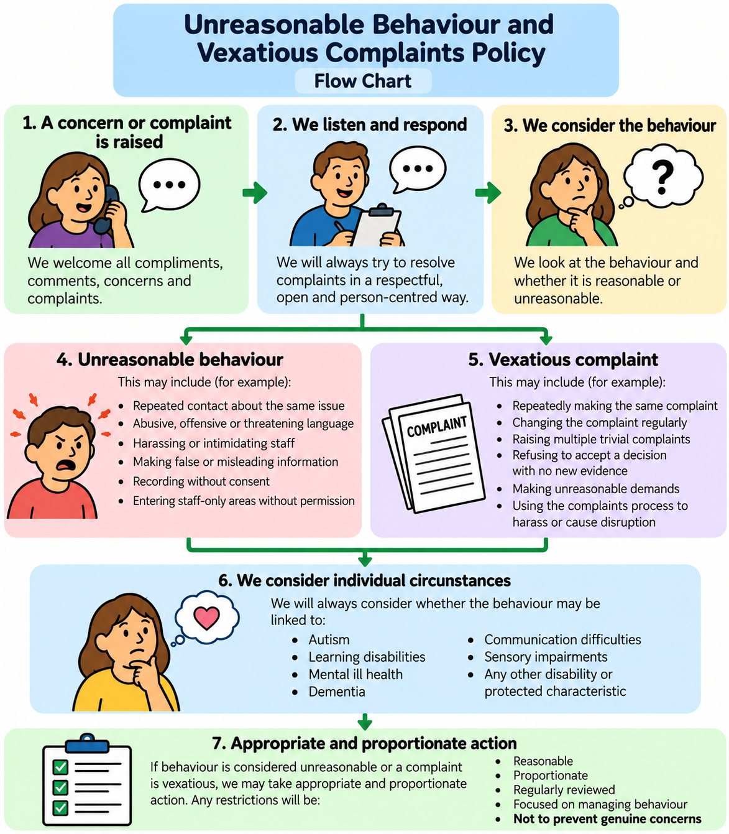

2- Unreasonable Behaviour and Vexatious Complaints Policy Easy Read

