

On-Call Policy for Family Members

1. Introduction
At Acorns Health Care, we recognise that families, representatives and those important to the people we support often need reassurance that help is available outside normal office hours. We understand that urgent situations can happen at any time and that knowing who to contact can provide confidence and peace of mind.
Our out-of-hours on-call service ensures that experienced managers are available to support staff in responding to urgent situations, safeguarding concerns and significant incidents when Head Office is closed. The service is designed to provide timely advice, decision-making and support to ensure the safety, wellbeing and continuity of care for the people we support.
The on-call system is intended for urgent matters that cannot safely wait until the next working day. Routine enquiries, requests for updates or administrative matters should be directed to the Home Manager or Head Office during normal office hours.
This policy explains how the on-call service operates, when it should be used, what families can expect when they contact the service and how information will be shared appropriately while respecting confidentiality, consent and legal responsibilities.

2. Purpose
The purpose of this policy is to provide a clear, consistent and transparent framework for how Acorns Health Care manages out-of-hours communication with families and representatives.
This policy aims to:
- Ensure urgent concerns are responded to promptly.
- Provide reassurance to families during emergencies.
- Promote safe and effective decision-making outside normal office hours.
- Ensure appropriate escalation of significant incidents.
- Protect the privacy, dignity and rights of the people we support.
- Clarify when the on-call system should and should not be used.
- Ensure compliance with safeguarding, confidentiality and regulatory requirements.

3. Scope
This policy applies to:
- Family members.
- Friends who have been authorised by the individual..
- Advocates.
- Representatives involved in an individual's care.
- All Acorns Health Care employees who participate in the on-call rota.

4. Policy Statement
Acorns Health Care is committed to ensuring that families and representatives can access appropriate support outside normal office hours when urgent situations arise.
The on-call service exists to support staff in managing emergencies safely and effectively while ensuring appropriate communication with families where this is lawful, appropriate and in the person's best interests.
The on-call manager provides advice, guidance and leadership to staff and will coordinate responses where required. Every contact will be assessed according to the level of urgency and risk, ensuring that immediate safety always remains the priority.
The on-call service is not intended to replace routine communication between families and the service. Regular updates, care planning discussions, complaints, compliments and general enquiries should continue to be directed to the Home Manager during office hours.

5. Out-of-Hours Contact Times
The on-call service operates during the following periods:
- Weekdays: 5:00 pm – 8:00 am
- Weekends: 24 hours per day
- Bank Holidays: 24 hours per day
Outside these hours, enquiries should be directed to the appropriate Manager

6. Contacting the On-Call Service
Where possible, family members should contact the support staff working in the home first.
The staff team will:
- Assess the immediate situation.
- Take any necessary actions to keep the person safe.
- Escalate concerns through the appropriate on-call management tier where required.
Families should not normally contact the on-call manager directly unless advised to do so or unless an emergency situation requires immediate escalation.

7. Appropriate Reasons to Contact the On-Call Service
The on-call service should only be used for urgent matters that cannot safely wait until the next working day.
Examples include:
- Significant deterioration in a person's health.
- Serious illness or injury.
- Medical emergencies.
- Missing person incidents.
- Safeguarding concerns.
- Serious accidents.
- Serious incidents affecting the safety of the home.
- Emergency staffing issues affecting safe care.
- Major property emergencies such as fire, flooding or loss of utilities.
- Situations requiring urgent management decisions.

8. Matters That Should Wait Until Office Hours
The on-call service should not normally be used for:
- Requests for routine updates.
- Questions about appointments.
- Compliments or complaints.
- Medication ordering.
- Finance enquiries.
- Staffing queries.
- General care planning discussions.
- Non-urgent maintenance requests.
- Requests for copies of documents.
These matters should be discussed with the Home Manager during normal working hours.

9. How the On-Call Service Responds
When an urgent concern is received, the on-call manager will:
- Assess the level of risk.
- Obtain relevant information from staff.
- Provide advice and guidance.
- Support staff to make safe decisions.
- Escalate concerns where necessary.
- Contact senior managers if required.
- Ensure safeguarding procedures are followed where appropriate.
- Record all decisions and actions taken.
Where appropriate, family members will be updated regarding actions taken, while respecting confidentiality and the wishes of the person receiving support.

10. Confidentiality and Information Sharing
Acorns Health Care is committed to protecting the privacy and rights of every individual.
Information will only be shared with family members where:
- The individual has consented to information being shared.
- The family member has legal authority, such as a Lasting Power of Attorney or Deputyship.
- Sharing information is necessary to protect the person's health, safety or wellbeing.
- Disclosure is required by law.
Where information cannot legally be shared, staff will explain this sensitively while continuing to provide reassurance wherever possible.

11. Emergencies
If there is an immediate threat to life or serious injury, emergency services should always be contacted first by dialling 999.
Examples include:
- Cardiac arrest.
- Serious injuries.
- Fires.
- Life-threatening medical emergencies.
- Violent incidents posing immediate danger.
The on-call manager should be informed as soon as it is safe to do so.

12. Professional Boundaries
The on-call service is designed to support the safe operation of services rather than provide routine communication.
Families can expect staff to:
- Be courteous and respectful.
- Listen carefully to concerns.
- Assess risks appropriately.
- Take urgent concerns seriously.
- Provide appropriate reassurance.
- Follow safeguarding procedures.
- Maintain confidentiality.
- Keep accurate records.
Staff will always remain professional and focused on ensuring the safety and wellbeing of the person receiving support.

13. Recording and Governance
All out-of-hours contacts will be documented in accordance with Acorns Health Care's recording procedures.
Records should include:
- Date and time.
- Person making contact.
- Nature of the concern.
- Risk assessment.
- Advice given.
- Actions taken.
- Escalation decisions.
- Follow-up required.
Learning from on-call contacts will be reviewed as part of Acorns Health Care's quality assurance and governance processes to identify trends, improve practice and strengthen the quality of our services.

14. Policy Review
This policy will be reviewed Biannually, or sooner if required following:
- Changes to legislation.
- Changes to CQC guidance.
- Learning from incidents.
- Safeguarding reviews.
- Serious incidents.
- Internal audits.
- Organisational changes.
- Identified risks or service improvements.

Version | 2
Date Reviewed | 04.10.2026
Policy Owner | Nominated Individual
Next Review Date | 03.10.2028
Review Frequency | Biannually
Applies To | Individuals, Families and Staff

Appendices;

1-On Call Policy for Family Members Flow Chart
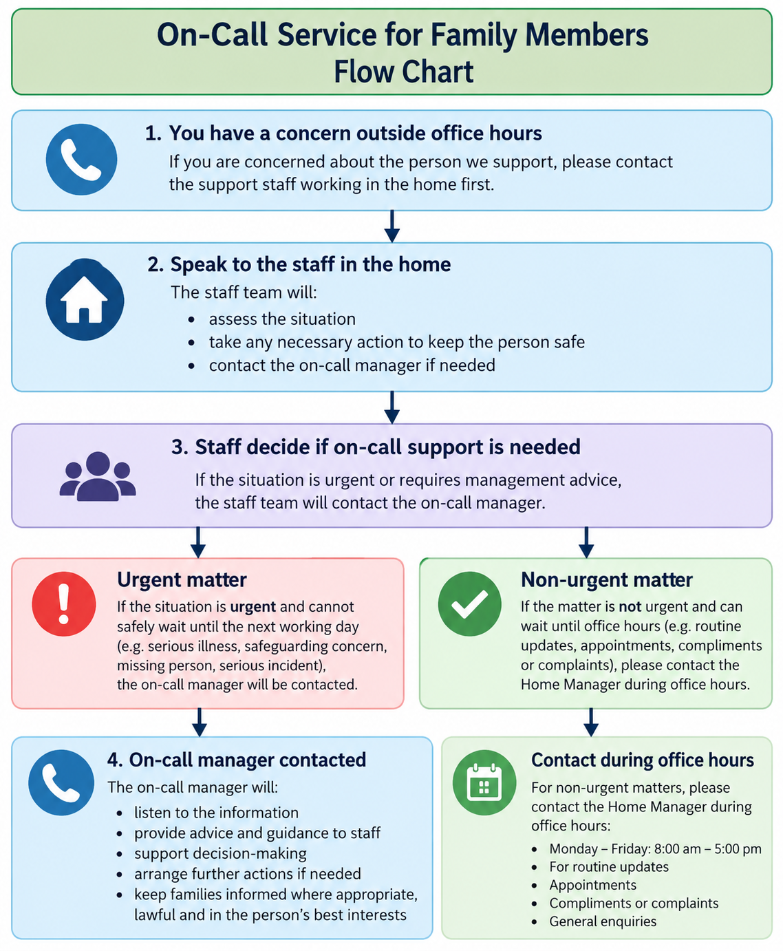

2- On Call Policy for Family Members Easy Read

