Modern Day Slavery and Human Trafficking Policy

1. Introduction and Policy Statement
Acorns Health Care is committed to providing safe, high-quality, person-centred care in an environment where the rights, dignity, freedom and wellbeing of every individual are respected and protected. We recognise that modern slavery and human trafficking are serious crimes and severe violations of human rights that can affect people of all ages, backgrounds and circumstances, including people who use our services, employees and members of the wider community.
As a provider of health and social care services, we have a legal and moral responsibility to safeguard people from abuse, neglect, exploitation and coercion. This includes recognising the signs of modern slavery, responding promptly to concerns and working in partnership with safeguarding authorities, the police and other relevant agencies to protect individuals who may be at risk.
Modern slavery includes human trafficking, forced or compulsory labour, domestic servitude, debt bondage, sexual exploitation, criminal exploitation (including county lines), child exploitation and other forms of abuse where individuals are controlled or exploited for another person's personal or financial gain.
Acorns Health Care has a zero-tolerance approach to modern slavery, human trafficking and exploitation in any form. We are committed to acting ethically, transparently and with integrity in all aspects of our work and expect the same high standards from our employees, volunteers, agency workers, contractors, suppliers and partner organisations.
This policy outlines how Acorns Health Care will prevent, identify, report and respond to concerns relating to modern slavery and human trafficking and should be read alongside our Safeguarding Adults Policy, Safeguarding Children Policy, Recruitment and Selection Policy, Whistleblowing Policy and Code of Conduct.

2. Purpose
The purpose of this policy is to:
- Protect people from modern slavery, exploitation and human trafficking.
- Ensure compliance with the Modern Slavery Act 2015 and other relevant legislation.
- Promote awareness of modern slavery throughout Acorns Health Care.
- Provide staff with guidance on recognising the indicators of exploitation.
- Ensure concerns are reported and managed appropriately.
- Promote ethical recruitment, employment and procurement practices.
- Protect vulnerable adults, children, employees and the wider community.

3. Scope
This policy applies to:
- Directors.
- Registered Managers.
- Employees.
- Agency workers.
- Bank staff.
- Volunteers.
- Students.
- Contractors.
- Suppliers.
- Consultants.
- Anyone acting on behalf of Acorns Health Care.
The policy also applies to all people receiving support from Acorns Health Care.

4. Legal and Regulatory Framework
This policy has been developed in accordance with:
- Modern Slavery Act 2015.
- Care Act 2014.
- Human Rights Act 1998.
- Equality Act 2010.
- Health and Social Care Act 2008 (Regulated Activities) Regulations 2014.
- Health and Safety at Work etc. Act 1974.
- Care Quality Commission (CQC) Fundamental Standards.
- Working Together to Safeguard Children.
- Local Authority Adult and Children's Safeguarding Procedures.
Acorns Health Care recognises that modern slavery is a safeguarding issue and will always respond in accordance with safeguarding legislation and guidance.

5. Definitions
Modern slavery is an umbrella term used to describe situations where an individual is exploited and cannot leave because of threats, coercion, deception or abuse of power.
Forms of modern slavery include:
- Human trafficking.
- Forced or compulsory labour.
- Domestic servitude.
- Debt bondage.
- Sexual exploitation.
- Criminal exploitation.
- County lines exploitation.
- Child exploitation.
- Forced criminality.
- Labour exploitation.
Victims may be adults or children and may not recognise themselves as victims due to fear, intimidation, language barriers or dependency on others.

6. Our Commitment
Acorns Health Care is committed to:
- Maintaining a zero-tolerance approach to modern slavery.
- Promoting a culture of openness, honesty and safeguarding.
- Respecting human rights.
- Supporting victims of exploitation.
- Maintaining safe recruitment practices.
- Working only with ethical suppliers wherever reasonably practicable.
- Reporting concerns promptly.
- Working collaboratively with safeguarding partners and law enforcement agencies.
- Providing staff with appropriate training and support.
Modern slavery will not be tolerated in any area of our organisation or business relationships.

7. Protecting People We Support
People receiving care and support may be particularly vulnerable to exploitation because of disability, age, illness, communication needs, mental ill health or social isolation.
Staff should remain alert to any signs that a person may be experiencing exploitation or abuse.
Possible indicators include:
- Fearful, withdrawn or anxious behaviour.
- Poor physical health or untreated injuries.
- Sudden changes in behaviour.
- Another person controlling conversations.
- Restricted movement.
- Lack of access to money or identification.
- Signs of neglect.
- Reluctance to speak openly.
- Unexplained absences.
- Concerns relating to county lines or criminal exploitation.
Where concerns are identified staff must:
- Ensure the person's immediate safety.
- Report concerns immediately to the Registered Manager.
- Follow Acorns Health Care safeguarding procedures.
- Complete safeguarding referrals where appropriate.
- Contact emergency services where there is an immediate risk of harm.
- Record concerns accurately and objectively.

8. Recruitment and Employment
Acorns Health Care is committed to fair, safe and lawful recruitment practices.
We will:
- Verify identity and right-to-work documentation.
- Carry out safer recruitment procedures.
- Obtain appropriate references.
- Complete Disclosure and Barring Service (DBS) checks where required.
- Ensure all contracts are freely agreed.
- Pay staff fairly and in accordance with employment legislation.
- Ensure staff retain possession of their own passports, bank cards and identity documents.
- Never charge recruitment fees.
- Never retain personal documents belonging to employees.
If concerns arise that an employee may themselves be a victim of exploitation, they will be treated with compassion and offered appropriate support whilst concerns are investigated through safeguarding and law enforcement agencies where necessary.

9. Contractors, Suppliers and Procurement
Acorns Health Care expects all suppliers, contractors and business partners to operate ethically and comply with the Modern Slavery Act 2015.
Where reasonably practicable we will:
- Carry out appropriate due diligence.
- Purchase goods and services from reputable organisations.
- Seek assurance that suppliers have suitable anti-slavery measures.
- Raise concerns where poor practice is identified.
- Review contracts where suppliers fail to meet expected standards.
Staff responsible for procurement should remain alert to any concerns relating to labour exploitation within supply chains.

10. Roles and Responsibilities

Directors
The Directors are responsible for ensuring effective governance arrangements are in place to prevent modern slavery and promote ethical working practices.

Senior Leadership Team
The Senior Leadership Team will:
- Ensure this policy is implemented.
- Promote a culture of safeguarding.
- Monitor compliance.
- Review incidents and learning.
- Ensure sufficient resources are available.

Registered Managers
Registered Managers are responsible for:
- Ensuring staff understand this policy.
- Managing concerns appropriately.
- Making safeguarding referrals.
- Liaising with external agencies.
- Supporting staff.
- Maintaining accurate records.

Employees
All employees must:
- Be vigilant to signs of exploitation.
- Attend mandatory training.
- Report concerns immediately.
- Follow safeguarding procedures.
- Maintain accurate records.
- Treat everyone with dignity and respect.

11. Reporting Concerns
Any concerns relating to modern slavery or human trafficking must be treated as safeguarding concerns.
Staff should immediately report concerns to:
- Their Registered Manager.
- The Regional Manager where appropriate.
- The Designated Safeguarding Lead.
Where someone is believed to be at immediate risk of harm or a crime has been committed, staff must contact the Police by calling 999.
Non-emergency concerns should be reported through safeguarding procedures and, where appropriate, to the Police by calling 101.
Concerns should also be referred to the relevant Local Authority Safeguarding Team.
All concerns must be documented factually and reported without delay.

12. Whistleblowing
Acorns Health Care encourages all employees to raise concerns regarding suspected modern slavery, unethical conduct or exploitation.
Employees raising concerns in good faith will be protected under the Whistleblowing Policy.
No employee will suffer discrimination, victimisation or detrimental treatment for reporting genuine concerns.

13. Training and Awareness
All employees will receive safeguarding training appropriate to their role.
Training will include:
- Modern slavery awareness.
- Human trafficking.
- Criminal exploitation.
- County lines.
- Labour exploitation.
- Recognising indicators.
- Reporting concerns.
- Safeguarding responsibilities.
Managers responsible for recruitment and procurement will receive additional training relevant to their responsibilities.
Training will form part of induction and mandatory refresher training.

14. Record Keeping and Confidentiality
Accurate records must be maintained whenever concerns relating to modern slavery are identified.
Records should:
- Be factual and objective.
- Be completed promptly.
- Be stored securely.
- Be shared only with those who have a legitimate need to know.
- Comply with the UK General Data Protection Regulation (UK GDPR) and Data Protection Act 2018.
Confidentiality should never prevent staff from sharing information where there are safeguarding concerns.

15. Monitoring and Review
Acorns Health Care will monitor compliance with this policy through:
- Safeguarding audits.
- Recruitment audits.
- Staff support sessions
- Training compliance.
- Incident reviews.
- Governance meetings.
Learning from incidents, safeguarding reviews and audits will be used to improve practice across the organisation.
This policy will be reviewed annually or sooner if there are changes in legislation, national guidance, CQC requirements or following significant incidents.
Version | 1
Date Reviewed | 26.07.2026
Policy Owner | Nominated Individual
Next Review Date | 25.07.2027
Review Frequency | Annually
Applies To | All employees, bank and agency workers and professionals

Appendices;

1- Modern Day Slavery and Human Trafficking Policy Flow Chart

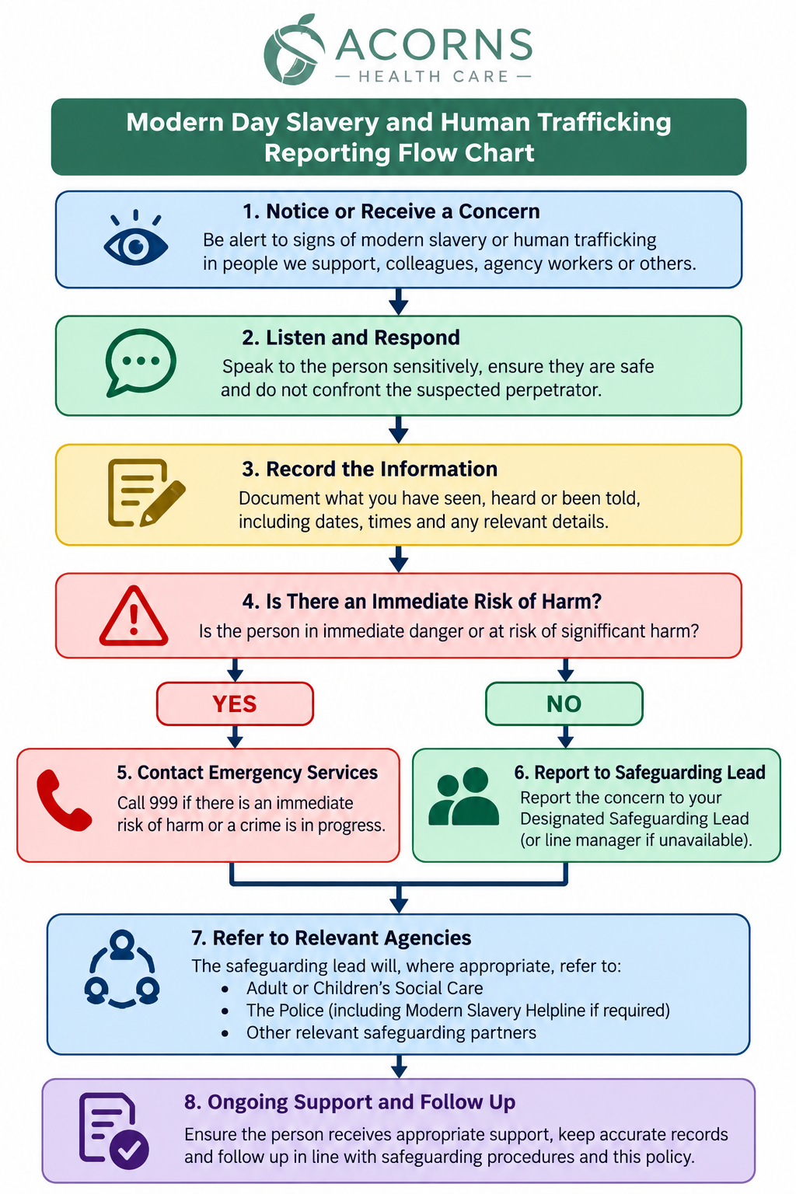

2-Modern Day Slavery and Human Trafficking Policy Easy Read

