

Mental Capacity Act Policy

1. Introduction
The Mental Capacity Act 2005 (MCA) provides the legal framework for making decisions on behalf of adults aged 16 years and over who may lack the mental capacity to make a specific decision at the time it needs to be made. The Act is founded on the principle that every person has the right to make their own decisions and must be supported to do so wherever possible.

At Acorns Health Care, we recognise that mental capacity practice is inseparable from human rights. Every individual has the right to be listened to, included and treated with dignity and respect. Regardless of communication needs, diagnosis or level of support, every effort will be made to understand an individual's wishes, preferences, feelings, beliefs and values so they can participate as fully as possible in decisions about their care, treatment, support and daily life.

This policy reflects Acorns Health Care's commitment to person-centred care, positive risk-taking, least restrictive practice and the protection and promotion of human rights, including the right to liberty and security, respect for private and family life, dignity and freedom from degrading treatment, and equality and non-discrimination.

This policy has been updated following the UK Supreme Court judgment of 2nd June 2026. The judgment changed the legal approach to determining whether care and living arrangements amount to a deprivation of liberty under Article 5 of the European Convention on Human Rights (ECHR). The change applies with immediate effect across the UK.

2. Purpose
Acorns Health Care is committed to promoting the rights, independence, dignity, wellbeing and inclusion of every individual we support.

The purpose of this policy is to ensure decisions are made in accordance with the Mental Capacity Act 2005 whilst empowering individuals to make as many decisions as possible about their own lives.

Where an individual lacks capacity to make a specific decision, Acorns Health Care will ensure any decision made on their behalf is lawful, person-centred, proportionate, clearly documented and made in their best interests.
Where care or support arrangements may restrict a person's liberty, Acorns Health Care will consider the person's specific circumstances, restrictions, wishes and feelings and the requirements of Article 5 ECHR, rather than applying a blanket test.

3. Scope
This policy applies to all Acorns Health Care employees, managers, agency workers, volunteers and contractors providing support to individuals aged 16 years and over.

4. Definitions
- Mental Capacity – A person's ability to understand, retain, use or weigh information relevant to a specific decision and communicate that decision.
- Mental Capacity Assessment – A decision-specific assessment completed where there is reason to believe an individual may lack capacity.
- Best Interest Decision – A decision made on behalf of a person who lacks capacity after considering all relevant circumstances, including the person's wishes, feelings, beliefs and values.
- IMCA – An Independent Mental Capacity Advocate appointed to represent individuals where required under the Mental Capacity Act.
- LPA – Lasting Power of Attorney appointed to make decisions on behalf of an individual where legally authorised.
- Deputy – A person appointed by the Court of Protection to make decisions on behalf of an individual where legally authorised.
- Deprivation of Liberty (DoL) – A restriction or combination of restrictions which, having regard to the person's specific situation and the type, duration, effects and manner of implementation, amounts to a deprivation of physical liberty for the purposes of Article 5 ECHR. The assessment is fact-specific and multifactorial; no single factor is determinative.
- Valid Consent to Care and Residence – For Article 5 purposes, the 2026 Supreme Court judgment confirms that a person who lacks legal capacity to make decisions about care and residence may, in some circumstances, still be capable of giving valid consent to arrangements that would otherwise amount to confinement. Valid consent is a distinct concept and depends on the person's expression of wishes and feelings and the circumstances. Where there is serious doubt, valid consent must not be inferred.

5. Policy Statement
Acorns Health Care believes that choice, independence, self-determination and liberty are fundamental human rights.
Every individual should have as much control over their life as possible and be actively involved in decisions affecting their care, support, health, finances, accommodation, relationships and future.
We will always:
- Presume capacity unless it is established otherwise for the specific decision.
- Take all practicable steps to support the individual to make their own decision.
- Respect unwise decisions where the person has capacity to make the relevant decision.
- Maximise communication, understanding and participation.
- Complete Mental Capacity Assessments where required.
- Place the person's wishes, feelings, beliefs and values at the centre of decision-making.
- Make decisions in the person's best interests only where capacity is lacking.
- Use the least restrictive option consistent with the person's rights and the purpose of the intervention.
- Consider whether care arrangements may amount to a deprivation of liberty and seek lawful authorisation where required.
- Never treat compliance, lack of objection or apparent happiness as automatically proving consent.

6. The Five Principles of the Mental Capacity Act

- Every adult must be assumed to have capacity unless established otherwise.
- Every practicable step must be taken to help a person make their own decision.
- A person is not to be treated as lacking capacity because they make an unwise decision.
- Any act or decision made on behalf of a person lacking capacity must be in their best interests.
- Any intervention must be the least restrictive of the person's rights and freedoms.
- These principles underpin every aspect of support provided by Acorns Health Care and should be read alongside the person's human rights under the Human Rights Act 1998.

7. Supporting Individuals to Make Their Own Decisions
Supporting individuals to make their own decisions is central to Acorns Health Care's values.
- Encourage individuals to express their wishes and preferences.
- Provide accessible information.
- Use communication aids, Easy Read documents, social stories and visual supports.
- Allow sufficient time for decisions.
- Choose suitable environments for important discussions.
- Involve those who know the individual well where appropriate.
- Respect cultural, religious and personal beliefs.
- Explore behaviour and non-verbal communication as possible expressions of wishes or feelings.
- Record the support provided and how the person's views were obtained.
- No individual should ever be excluded from decision-making because they require additional support to communicate.

8. Mental Capacity Assessment and Best Interest Decision Process
At the earliest appropriate opportunity following admission, Acorns Health Care will consider whether a Mental Capacity Assessment is required where there is reason to believe an individual may lack capacity to make specific decisions relating to their care, treatment, support, accommodation, finances or other significant aspects of their life.

Mental Capacity Assessments are decision-specific and time-specific and must never be based solely on diagnosis, disability, behaviour or communication needs.
Before determining that an individual lacks capacity, staff must take all practicable steps to support them to make their own decision.

The process includes:
- Identifying the decision.
- Presuming capacity.
- Providing all practicable support.
- Completing a Mental Capacity Assessment where appropriate.
- Recording the assessment and outcome.
- Updating care plans, risk assessments and PBS plans where necessary.
Where an individual is assessed as lacking capacity to make a significant decision, Acorns Health Care will arrange a Best Interest Meeting where appropriate.

The meeting will include the individual wherever possible and, where appropriate:
- Family members.
- Lasting Power of Attorney.
- Court Appointed Deputies.
- Independent Mental Capacity Advocates.
- Health and social care professionals.
- Others who know the individual well.

The purpose of the meeting is to ensure decisions reflect the person's wishes, feelings, beliefs and values while identifying the least restrictive option.

Mental Capacity Assessments and Best Interest decisions will be reviewed at least annually, or sooner where:
- Capacity changes.
- Restrictions change.
- Care or accommodation changes.
- New information becomes available.
- Significant events occur.

All assessments and Best Interest decisions must be clearly documented.

9. Human Rights and Deprivation of Liberty – Updated Legal Position
People who receive care and support have the same human rights as everyone else. A person's disability, cognitive impairment or lack of mental capacity does not reduce the value of their rights.
Article 5 ECHR protects the right to liberty and security of person. Article 8 protects respect for private and family life, home and personal autonomy. Other Convention rights may also be relevant depending on the circumstances.

Following the Supreme Court judgment in 2026, Acorns Health Care must no longer apply the former Cheshire West 'acid test' as a standalone or automatic test for deprivation of liberty. The Supreme Court held that the assessment is multifactorial and starts with the specific situation of the individual, considering the type, duration, effects and manner of implementation of the restrictions. No single factor is determinative.

The judgment also confirms that lack of legal capacity to make a decision about care and residence does not automatically mean that a person cannot give valid consent to arrangements. Valid consent is an autonomous concept for Article 5 purposes. A person may, in some circumstances, give valid consent where they are conscious of their environment, have a basic level of understanding and can express a view that they accept and/or are happy with the arrangements. Where there is serious doubt, no inference of valid consent should be drawn.

A person's wishes and feelings are therefore important evidence. Objection may be expressed verbally or through actions and behaviour. Examples may include trying to leave, distress, physical rejection of care or restraint, or other communication indicating that the person does not accept the arrangements. Staff must not interpret behaviour automatically; the context and possible reasons for the behaviour must be considered. The person must be supported to communicate their wishes and feelings.

Where there is reason to believe that a person may be deprived of liberty, the relevant legal safeguards remain necessary. In England, DoLS continues to apply in hospitals and registered care homes where the statutory scheme applies, while the Court of Protection route applies to deprivation of liberty in other settings such as supported living. Where there is doubt about whether arrangements amount to a deprivation of liberty or whether valid consent is present, the matter should be referred for appropriate review rather than resolved through assumption.

10. Assessing Whether Arrangements Amount to a Deprivation of Liberty
Where a person may be subject to restrictions in supported living or another community setting, staff and managers must consider the person's actual circumstances rather than applying a blanket assumption.

The assessment should consider, in particular:
- The person's specific situation, wishes, feelings and any expressed acceptance or objection.
- The type of restrictions being used, such as locked doors, supervision, physical control, medication or social isolation.
- The duration and frequency of the restrictions.
- The effects of the restrictions on the person.
- The manner in which the restrictions are implemented.
- Whether the person objects and, if so, how that objection is expressed.
- The person's awareness and understanding of the arrangements.
- How far the arrangements are removed from the paradigm of confinement, including the relative normality of the arrangements in the person's circumstances.
- The purpose of the arrangements, recognising that purpose is relevant but is not decisive.
- Whether the restrictions are necessary and proportionate to the identified purpose or risk.
- Whether there is a less restrictive alternative.
- Any changes in circumstances or new evidence about the person's wishes, feelings or the effect of restrictions.

No single factor is decisive. The question is whether, considering the person's concrete situation as a whole, the arrangements amount to a deprivation of liberty under Article 5 ECHR. The Supreme Court emphasised that difficult or borderline cases require a practical and realistic approach and that, where there is serious doubt, valid consent should not be inferred.

Importantly, the fact that a person's illness, condition or impairment itself limits their ability to leave is not, without more, sufficient to establish a deprivation of liberty. The assessment must consider whether restrictions are being imposed on the person against their will.

11. Restrictions and Least Restrictive Practice
Restrictions should only be introduced where necessary, lawful and proportionate, and after less restrictive alternatives have been considered.
Examples may include:

- Supervision in the community.
- Medication management.
- Financial management.
- Environmental adaptations.
- Positive Behaviour Support strategies.
- Technology used to promote safety.
- Restrictions on access to particular areas or items.
- Physical intervention or restraint where lawfully required.

Every restriction must be:
- Individually assessed.
- Necessary and proportionate.
- The least restrictive option reasonably available.
- Supported by appropriate Mental Capacity Assessments where required.
- Considered in light of the person's wishes and feelings.
- Clearly documented.
- Regularly reviewed and reduced or removed when no longer required.

Restrictions must never be implemented for staff convenience.
Where a restriction or combination of restrictions may amount to a deprivation of liberty, the matter must be escalated promptly to the manager and the appropriate local authority or Court of Protection process considered.

12. Supported Living and Human Rights
People living in supported living have the same legal rights as everyone else. Acorns Health Care will promote independence, dignity, choice, positive risk-taking, privacy, relationships and community participation.

A supported living placement must not be treated as an institutional environment. The person's home should be respected as their home, and support should be arranged around the person's rights, wishes and ordinary life as far as possible.

Where restrictions are significant, persistent or combined in a way that may affect liberty, managers must ensure a structured, person-specific assessment is completed, and appropriate legal advice or authorisation is obtained where required.

Individuals must always be involved in discussions about restrictions wherever possible, including through appropriate communication support.

13. Independent Mental Capacity Advocates, Attorneys and Deputies

Acorns Health Care will work collaboratively with:
- Independent Mental Capacity Advocates (IMCAs).
- Attorneys appointed under a Lasting Power of Attorney.
- Court Appointed Deputies.
- Family members.
- Health and Social Care professionals.
Their views will be considered alongside the individual's wishes and preferences when Best Interest decisions are required. The legal authority of an attorney or deputy must be understood and respected.

14. Documentation and Record Keeping
The following documentation must be maintained where relevant:
- Mental Capacity Assessments.
- Best Interest Meeting records.
- Care Plans.
- Risk Assessments.
- Positive Behaviour Support Plans.
- Capacity reviews.
- Best Interest reviews.
- Records of restrictions and restrictive practices.
- DoLS or Court of Protection documentation where applicable.
- Documentation must demonstrate:
- How the individual was involved.
- The support provided to help the person decide or communicate.
- Their wishes, feelings, beliefs and values.
- Any acceptance, objection or uncertainty about the arrangements.
- Who was consulted.
- The restrictions in place and their type, duration, effects and manner of implementation.
- Why the least restrictive option was chosen.
- Why any deprivation of liberty authorisation or legal referral was required or not required.
- When the arrangements will be reviewed.

Records must be factual, respectful and person-centred. Staff should record what they observed and what the person communicated rather than making assumptions about what the person 'cannot cope with', 'does not understand' or 'is happy with' without evidence.

15. Roles and Responsibilities
Managers
- Ensuring this policy is implemented.
- Ensuring Mental Capacity Assessments are completed where required.
- Arranging Best Interest Meetings where appropriate.
- Reviewing restrictions and possible deprivation of liberty using the current legal framework.
- Ensuring documentation is accurate and reflects the person's voice.
- Ensuring staff receive training and understand the current legal position.
- Escalating concerns to the appropriate local authority, safeguarding team or Court of Protection route where required.

Employees
- Promoting choice and independence.
- Seeking consent wherever possible.
- Supporting individuals to make decisions.
- Listening to and recording wishes and feelings.
- Recognising and reporting restrictions that may affect liberty.
- Using the least restrictive approach.
- Escalating concerns.
- Respecting the rights of every individual.

16. Training

All staff will receive Mental Capacity Act training during induction and regular refresher training thereafter.

Training will include the relationship between the MCA, human rights, consent, best interests, least restrictive practice, restrictive practices and deprivation of liberty.

Managers will ensure staff remain competent in applying the Act and promoting person-centred practice. Training and local guidance will be updated as further national guidance is issued following the 2026 Supreme Court judgment.

17. Monitoring and Governance
Compliance will be monitored through:
- Care plan audits.
- Mental Capacity Assessment audits.
- Best Interest Meeting audits.
- Restriction and restrictive-practice audits.
- DoLS and Court of Protection case reviews where applicable.
- Support Sessions and supervision.
- Quality assurance.
- Safeguarding and incident reviews.
- Feedback from individuals, families, advocates and professionals.
- Learning from audits, incidents, legal developments and feedback will be used to continually improve practice.
- Managers must ensure this policy and associated operational documents are reviewed following relevant changes in legislation, case law or national guidance.

- 18. Legislation, Case Law and Guidance
- Mental Capacity Act 2005.
- Mental Capacity Act Code of Practice.
- Human Rights Act 1998 and the European Convention on Human Rights.
- Health and Social Care Act 2008 (Regulated Activities) Regulations 2014.
- Care Act 2014.
- Supreme Court: A Reference by the Attorney General for Northern Ireland – [2026] UKSC 16, judgment dated 2 June 2026.
- Department of Health and Social Care: UK Supreme Court 2026 judgment on what constitutes a deprivation of liberty, updated 22 September 2026.
- Relevant current local authority, NHS and safeguarding guidance.
- The 2026 Supreme Court judgment is authoritative for the current Article 5 approach. Acorns Health Care will also follow subsequent statutory guidance and case law as it is published.

19. Review
This policy will be reviewed every 12 months or sooner if legislation, national guidance or relevant case law changes. An earlier review is required where further national guidance is issued following the 2026 Supreme Court judgment.

Version | 2
Date Reviewed | 23.07.2026
Policy Owner | Nominated Individual
Next Review Date | 22.07.2027
Review Frequency | Annually
Applies To | Individuals, staff, family and professionals

Appendices;

- Mental Capacity Act Policy Flow Chart

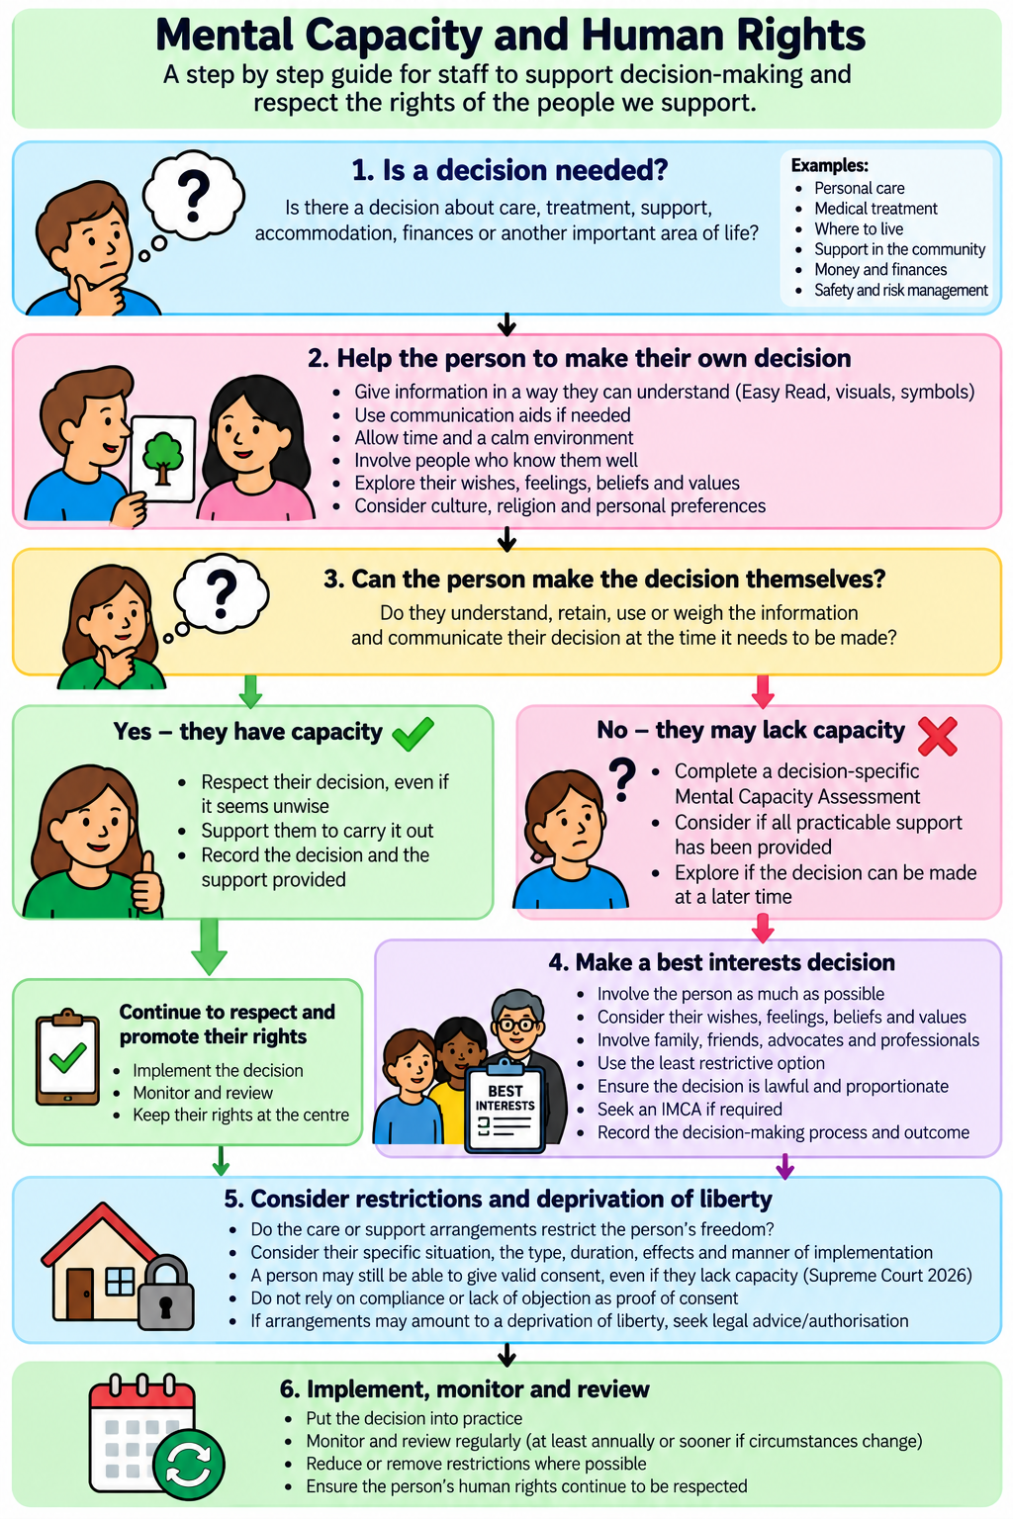

Appendices;

- Mental Capacity Act Policy Easy Read

