Involving People in Their Care Policy

1.Introduction
At Acorns Health Care, we believe that people should be active partners in planning, delivering and reviewing their care and support. Meaningful involvement is fundamental to providing high-quality, person-centred care that promotes dignity, independence, wellbeing and positive outcomes. We recognise that every individual is the expert in their own life, with unique experiences, preferences, aspirations and goals that should shape the support they receive.
As a provider of supported living and domiciliary care services, Acorns Health Care is committed to ensuring that people are empowered to make informed choices, exercise control over their lives and participate in decisions that affect them. We understand that involvement is not limited to formal care planning meetings but should be embedded in every interaction, every day.
Within supported living services, individuals are tenants in their own homes. They have the same rights, freedoms and responsibilities as any other tenant, including the right to privacy, independence, choice and control over their home environment. Staff are guests within a person's home and must work alongside individuals, supporting rather than directing or controlling their lives.
We recognise that some people may require additional support to participate fully in decisions because of communication needs, cognitive impairment, sensory impairment or fluctuating capacity. Where this is the case, we will make reasonable adjustments, provide accessible information and work collaboratively with families, advocates and professionals to maximise involvement while respecting the individual's rights and preferences.
Our approach is underpinned by the principles of the Mental Capacity Act 2005, the Care Act 2014, the Human Rights Act 1998 and the Equality Act 2010. We are committed to promoting choice, independence and positive risk-taking while ensuring that care remains safe, proportionate and person centred.
This policy reflects the expectations of the Care Quality Commission (CQC) Single Assessment Framework and demonstrates Acorns Health Care's commitment to delivering services that are safe, effective, caring, responsive and well-led.

2. Purpose
The purpose of this policy is to ensure that every person supported by Acorns Health Care is meaningfully involved in decisions about their care, treatment and support, enabling them to exercise choice, maintain independence and achieve the best possible quality of life.

The policy aims to:
- Promote person-centred care and shared decision-making.
- Support individuals to make informed choices about their lives and care.
- Encourage independence, autonomy and self-determination.
- Ensure communication is accessible and tailored to individual needs.
- Promote dignity, respect and equality in all aspects of care.
- Support compliance with legislation, national guidance and CQC requirements.
- Encourage partnership working with families, advocates and professionals where appropriate.
- Ensure care planning reflects what matters most to each person
- Promote continuous improvement through meaningful involvement and feedback.

3. Scope
This policy applies to:
- All people supported by Acorns Health Care.
- Employees, including permanent, temporary, bank and agency workers.
- Volunteers, apprentices and students.
- Registered Managers and members of the Senior Leadership Team.
- Directors and the Nominated Individual.
- Contractors and professionals working alongside Acorns Health Care.
- Families, advocates and representatives, where appropriate and with the individual's consent or where legally authorised.
The principles within this policy apply to every stage of assessment, care planning, service delivery, review, quality assurance and service development.

4. Policy Statement
Acorns Health Care is committed to ensuring that people are fully involved in every aspect of their care and support.
We believe that individuals have the right to:
- Be listened to and treated with dignity and respect.
- Make informed decisions about their own lives.
- Receive information in a way they can understand.
- Be supported to express their views, wishes and preferences.
- Participate in planning, reviewing and evaluating their care.
- Take positive risks that support independence and personal growth.
- Receive care that reflects their individual goals, strengths and aspirations.

- Access advocacy where additional support is required.
- Be involved in decisions even where they lack capacity, to the greatest extent possible.
Care and support will always be delivered in partnership with the individual, recognising their rights, abilities and personal choices.

5. Our Commitment to Involving People in Their Care
Acorns Health Care is committed to creating a culture where involvement is embedded in everyday practice rather than viewed as a one-off event.
We will:
- Listen to what matters most to each individual.
- Respect personal choices, beliefs, values and aspirations.
- Encourage people to exercise as much independence as possible.
- Provide accessible information to support informed decision-making.
- Enable individuals to participate in all decisions affecting their lives.
- Support people to develop confidence, skills and independence.
- Promote positive risk-taking that balances choice with safety.
- Work collaboratively with families, advocates and professionals where appropriate.
- Continually review care to ensure it reflects changing needs and personal goals.
- Encourage individuals to influence how services are delivered and developed.
We recognise that meaningful involvement improves wellbeing, strengthens relationships, enhances confidence and leads to better outcomes for the people we support.

6. Principles of Person-Centred Involvement
At Acorns Health Care, involvement is founded on the principles of person-centred care, recognising that every individual is unique and should be supported to live the life they choose.
Our approach is based upon the following principles:
- Every person has the right to be heard and respected.
- Individuals should be involved in decisions that affect them.
- Communication should be personalised and accessible.
- Independence should be promoted wherever possible.
- Risks should be managed in ways that support choice rather than unnecessarily restrict opportunities.
- Care should build on people's strengths, abilities and aspirations.
- Individuals should be treated as equal partners in planning and delivering their support.

- Families, advocates and professionals should work collaboratively while respecting the individual's wishes and rights.
- Care and support should remain flexible and responsive to changing needs.
Meaningful involvement is an ongoing process that takes place every day through conversations, shared decision-making and collaborative care planning. It should be evident in all aspects of service delivery and reflected within care records, reviews and quality assurance processes.

7. Supporting Choice, Independence and Decision-Making
Acorns Health Care believes that every individual has the right to make choices about their own life and should be supported to exercise as much independence as possible. We recognise that choice and control are fundamental to wellbeing, self-esteem and achieving positive outcomes.
Staff will actively encourage individuals to make informed decisions about all aspects of their daily lives, recognising that involvement extends beyond formal care planning and should be embedded in everyday interactions.
Individuals will be supported to make choices about:
- Their daily routines and activities.
- Personal care and appearance.
- Meals, nutrition and hydration.
- Clothing and personal belongings.
- Social relationships and visitors.
- Education, employment and volunteering opportunities.
- Community participation and leisure activities.
- Healthcare appointments and treatment options.
- Cultural, religious and spiritual practices.
- Goals, aspirations and future planning.

Where individuals choose to take positive risks, staff will work collaboratively to identify appropriate support and risk management measures that enable opportunities while maintaining safety. Decisions will always be proportionate, person centred and focused on achieving the least restrictive outcome.
Staff must never make assumptions about an individual's ability to make decisions based on age, disability, diagnosis, communication needs or appearance. Every individual must be given the opportunity, support and time required to express their views and make informed choices.

8. Communication and Accessible Information
Meaningful involvement can only be achieved when individuals are able to understand information, communicate their wishes and participate fully in discussions about their care and support.
Acorns Health Care is committed to providing information in formats that meet each person's communication needs and to making reasonable adjustments to remove barriers to participation.
Staff will:
- Identify and record communication needs during assessment.
- Provide information in clear, accessible and appropriate formats.
- Use communication methods that reflect individual preferences.
- Encourage individuals to express their views in ways that are meaningful to them.
- Regularly review communication needs and update care records accordingly.
Reasonable adjustments may include:
- Easy Read documents.
- Large print information.
- Picture symbols and visual aids.
- Communication passports.
- Social stories.
- British Sign Language interpreters.
- Translation and interpreting services.
- Assistive technology.
- Electronic communication devices.
- Visual timetables and schedules.
- Objects of reference where appropriate.
Acorns Health Care will comply with the Accessible Information Standard and ensure that communication barriers do not prevent individuals from participating in decisions about their care.
Staff should allow sufficient time for conversations, avoid unnecessary jargon and regularly check understanding before seeking consent or making decisions.

9. Mental Capacity, Consent and Best Interests
Acorns Health Care is committed to supporting every individual to make their own decisions wherever possible.
Where there are concerns about an individual's ability to make a specific decision, staff must follow the principles of the Mental Capacity Act 2005.

The five statutory principles of the Mental Capacity Act will underpin all decision-making:
- Every adult has the right to make their own decisions and must be presumed to have capacity unless it is established otherwise.
- Individuals must be given all practicable support before it is concluded that they cannot make a decision.
- People have the right to make unwise decisions.
- Any decision made on behalf of someone lacking capacity must be made in their best interests.
- Any action or decision must be the least restrictive of the person's rights and freedoms.
Where a person lacks capacity to make a specific decision, Acorns Health Care will ensure that:
- A decision-specific capacity assessment is completed.
- Best interest decisions involve the individual as much as possible.
- Families, advocates and relevant professionals are consulted where appropriate.
- Independent Mental Capacity Advocates (IMCAs) are involved where required by legislation.
- Decisions are fully documented and regularly reviewed.
Consent must always be sought before providing care or treatment.
Valid consent must be:
- Given voluntarily.
- Based upon sufficient information.
- Specific to the decision.
- Given by a person with capacity to make that decision.
Consent is recognised as an ongoing process rather than a one-off event and should be reviewed whenever circumstances change.

10. Person-Centred Care Planning
Care planning is a collaborative process that places the individual at the centre of decisions about their care and support.
Care plans will be developed in partnership with the individual and, where appropriate and with consent, their family, advocate or other professionals involved in their care.
Care plans will reflect:
- What matters most to the individual.
- Personal strengths and abilities.
- Preferences and daily routines.

- Cultural, religious and spiritual beliefs.
- Communication needs.
- Health and wellbeing goals.
- Desired outcomes and aspirations.
- Relationships and social networks.
- Community involvement.
- Risks and agreed strategies for managing them.
- Opportunities to develop independence and life skills.
Individuals will receive copies of their care plans in an accessible format where appropriate and will be encouraged to review and contribute to updates on an ongoing basis.
Care plans will be reviewed regularly and whenever there is a significant change in the individual's needs, wishes or circumstances.

11. Involvement in Everyday Care and Support
Meaningful involvement is demonstrated through everyday practice rather than solely during formal reviews.
Staff will ensure that individuals are actively involved in decisions throughout each day by:
- Asking how they would like support to be provided.
- Offering genuine choices wherever possible.
- Respecting personal routines and preferences.
- Encouraging people to complete tasks independently where they are able.
- Supporting individuals to learn new skills and increase independence.
- Respecting privacy within their own home.
- Seeking permission before entering private spaces or handling personal belongings.
- Encouraging participation in household tasks where this reflects the individual's wishes and goals.
- Supporting individuals to access education, employment, volunteering and community activities.
- Promoting meaningful relationships and social inclusion.
Within supported living, staff must always remember that they are supporting people in their own homes. Individuals retain control over their living environment, daily routines and lifestyle choices, and support should be delivered in a way that respects tenancy rights, promotes independence and enables people to live the lives they choose.
Staff should continually encourage individuals to develop confidence, build skills and take an active role in directing their own care and support.

12. Working in Partnership with Families, Advocates and Professionals
Acorns Health Care recognises that effective partnership working is essential to delivering high-quality, person-centred care. We value the knowledge, experience and contributions of families, advocates and professionals and understand that collaborative working supports better outcomes for the people we support.
The individual will always remain at the centre of decision-making. Families, representatives and professionals will be involved with the individual's consent, or where there is a legal basis to do so, ensuring that the person's wishes, rights and preferences continue to guide care and support.
Acorns Health Care will work collaboratively with:
- Family members and those important to the individual.
- Independent advocates and Independent Mental Capacity Advocates (IMCAs).
- General Practitioners (GPs).
- Community nurses and specialist healthcare professionals.
- Social workers and Local Authorities.
- Commissioners and Integrated Care Boards (ICBs).
- Therapists, psychologists and Positive Behaviour Support practitioners.
- Educational providers, employers and vocational services where appropriate.
- Other care providers involved in supporting the individual.
Partnership working will be based upon:
- Open, honest and respectful communication.
- Sharing relevant information appropriately and lawfully.
- Clearly defined roles and responsibilities.
- Mutual respect for professional expertise.
- Joint decision-making that reflects the individual's wishes and best interests.
- Regular review of care and agreed outcomes.
Where there is disagreement between those involved in an individual's care, every effort will be made to resolve concerns through discussion and collaborative planning, always placing the individual's rights, wellbeing and best interests at the centre of decision-making.

13. Feedback, Complaints and Service Development
Acorns Health Care is committed to creating a culture where people feel listened to, valued and empowered to influence the services they receive.
People we support, families, advocates, professionals and employees are encouraged to provide feedback about the quality of care, support and service delivery. Feedback helps us understand

what is working well, identify opportunities for improvement and ensure our services continue to meet the needs and expectations of those we support.
Feedback may be gathered through:
- Care plan reviews.
- Surveys.
- Compliments and complaints.
- Informal conversations.
- Family and professional meetings.
- Quality assurance visits.
Individuals will be supported to raise concerns or make complaints in a way that is accessible and appropriate to their communication needs.
All concerns and complaints will be:
- Acknowledged promptly.
- Investigated fairly and objectively.
- Responded to within agreed timescales.
- Used to improve practice and service quality.
- Shared appropriately as part of organisational learning.
Acorns Health Care is committed to ensuring that no person experiences disadvantage or negative consequences for raising concerns or expressing their views.
We actively encourage people to contribute to the development and improvement of our services by participating in consultations, surveys, meetings and quality improvement initiatives. Their experiences and feedback are central to shaping responsive, person-centred services.

14. Roles and Responsibilities

The Nominated Individual and Senior Leadership Team
The Nominated Individual and Senior Leadership Team are responsible for:
- Promoting a culture where people are actively involved in decisions about their care and support.
- Ensuring sufficient governance arrangements are in place to support person-centred practice.
- Monitoring compliance with legislation, regulations and this policy.
- Providing adequate resources to support meaningful involvement.
- Reviewing organisational performance and driving continuous improvement.

Registered Managers
Registered Managers are responsible for:
- Ensuring this policy is implemented consistently across their service.
- Promoting person-centred values and inclusive practice.
- Supporting employees through support sessions, appraisal and reviews
- Ensuring care plans demonstrate meaningful involvement.
- Monitoring feedback, complaints and quality assurance findings.
- Addressing barriers that may prevent people from participating in decisions about their care.
- Promoting partnership working with families, advocates and professionals.

Employees
Every employee has a responsibility to:
- Treat individuals with dignity, respect and compassion.
- Encourage choice, independence and informed decision-making.
- Support people to express their views, wishes and preferences.
- Use accessible communication methods appropriate to the individual.
- Promote positive risk-taking while maintaining safety.
- Respect people's homes, privacy and tenancy rights.
- Record individual choices, preferences and agreed outcomes accurately.
- Report concerns where involvement is not being promoted.
- Complete mandatory training and maintain professional competence.
- Reflect on their own practice and continually seek to improve the quality of support they provide.
Employees should recognise that involving people in their care is an ongoing process that should be evident in every interaction, not limited to formal meetings or reviews.

15. Training and Competency
Acorns Health Care is committed to ensuring that all employees have the knowledge, skills and confidence to promote meaningful involvement, person-centred care and shared decision-making.
Training will support employees to understand both the legal requirements and the practical skills required to involve people in all aspects of their care and support.
Mandatory training will include, where appropriate:
- Person-Centred Care.
- Communication skills.

- Equality, Diversity and Inclusion.
- Human Rights.
- Mental Capacity
- Consent.
- Positive Behaviour Support.
- Autism awareness and learning disability awareness where relevant.
- Accessible communication.
- Safeguarding Adults.
- Promoting independence and positive risk-taking.
Training will be provided during induction and refreshed in accordance with organisational requirements and best practice guidance.
Managers will support ongoing learning through:
- Support sessions
- Observation of practice.
- Competency assessments.
- Team meetings.
- Learning following incidents, complaints and feedback.
Where competency gaps are identified, additional coaching, mentoring or training will be provided to ensure employees remain confident and competent in delivering person-centred care.

16. Record Keeping and Confidentiality
Accurate and person-centred record keeping is essential to demonstrating that individuals have been involved in planning, reviewing and directing their care and support.
Records must:
- Accurately reflect the individual's wishes, preferences and decisions.
- Clearly document discussions, agreed outcomes and any support provided to enable decision-making.
- Record consent, capacity assessments and Best Interest decisions where appropriate.
- Reflect reasonable adjustments made to support communication and involvement.
- Be written using respectful, objective and person-centred language.
- Be completed promptly and stored securely.
Information will be managed in accordance with the Data Protection Act 2018, UK General Data Protection Regulation (UK GDPR) and Acorns Health Care's Confidentiality and Information Governance policies.

Information will only be shared with others where there is a lawful basis to do so and where it supports the individual's care, safety or legal rights.

17. Governance, Monitoring and Continuous Improvement
Acorns Health Care is committed to ensuring that involving people in their care is embedded throughout the organisation and remains central to the delivery of safe, effective, caring, responsive and well-led services. Effective governance arrangements enable the organisation to monitor compliance, evaluate outcomes and continually improve the quality of person-centred care.
The organisation will monitor compliance with this policy through:
- Quality assurance audits.
- Care plan and documentation reviews.
- Observation of care and support practice.
- Support sessions and competency assessments.
- Feedback from people we support, families and professionals.
- Complaints, compliments and concerns.
- Incident, safeguarding and learning reviews..
- Internal governance meetings.
- External inspections and regulatory reviews.
Monitoring activities will seek to ensure that:
- Individuals are actively involved in planning, reviewing and directing their care.
- Care plans accurately reflect individual wishes, preferences and aspirations.
- Communication needs and reasonable adjustments are identified and met.
- Consent and Mental Capacity Act processes are followed appropriately.
- Positive risk-taking and independence are promoted.
- Staff demonstrate person-centred values in everyday practice.
- Opportunities for learning and service improvement are identified and implemented.
Learning identified through audits, incidents, complaints, safeguarding concerns, compliments, feedback or changes in legislation will be used to improve practice, strengthen governance and enhance the quality of care provided across all Acorns Health Care services.
The organisation encourages a culture of openness, reflection and continuous learning, recognising that meaningful involvement is essential to achieving positive outcomes and improving quality of life for the people we support.

18. Legislation and Guidance
This policy has been developed with reference to the following legislation and national guidance:
- Health and Social Care Act 2008 (Regulated Activities) Regulations 2014.
- Care Act 2014.
- Mental Capacity Act 2005 and Code of Practice.
- Human Rights Act 1998.
- Equality Act 2010.
- Data Protection Act 2018.
- UK General Data Protection Regulation (UK GDPR).
- NHS Accessible Information Standard.
- Care Quality Commission (CQC) Single Assessment Framework.
- Skills for Care – Person-Centred Care Guidance.
- Relevant National Institute for Health and Care Excellence (NICE) guidance.
Acorns Health Care will ensure that policies, procedures and working practices remain aligned with current legislation, national guidance and regulatory expectations.

19. Policy Review
This policy will be reviewed biannually, or sooner where required, to ensure it remains current, effective and reflective of changes in legislation, guidance and organisational practice.
An earlier review may be required following:
- Changes in legislation or statutory guidance.
- Updates to Care Quality Commission regulations.
- Learning from audits, inspections, safeguarding concerns or complaints.
- Significant organisational changes.
- Changes to best practice guidance.
- Feedback from people we support, families, advocates, employees or partner organisations.
Responsibility for reviewing this policy rests with the Nominated Individual, in consultation with the Senior Leadership Team, Registered Managers and other relevant stakeholders.
Any amendments will be communicated through Acorns Health Care's policy management process and incorporated into induction, mandatory training, support sessions and quality assurance activities to ensure employees remain informed and competent.

20. Conclusion

At Acorns Health Care, we believe that meaningful involvement is fundamental to delivering exceptional, person-centred care. Every individual has the right to be listened to, respected and supported to make decisions about their own life, regardless of the level of support they require.
By promoting choice, independence, partnership working and accessible communication, we empower people to remain at the centre of their care and support. We recognise that involvement is not a one-off event but a continuous process that should be evident in every interaction, every decision and every aspect of service delivery.
Through strong leadership, effective governance, ongoing learning and a commitment to continuous improvement, Acorns Health Care will continue to foster a culture where individuals are empowered to achieve their personal goals, maintain their independence and live fulfilling lives with dignity, respect and control over the support they receive.

Version | 3
Date Reviewed | 04.10.2026
Policy Owner | Nominated Individual
Next Review Date | 03.10.2028
Review Frequency | Biannually
Applies To
  People we support, employees, bank and agency workers, volunteers, contractors, professionals, families, advocates and visitors

Appendices;

1-Involving People in Their Care Policy Flow Chart

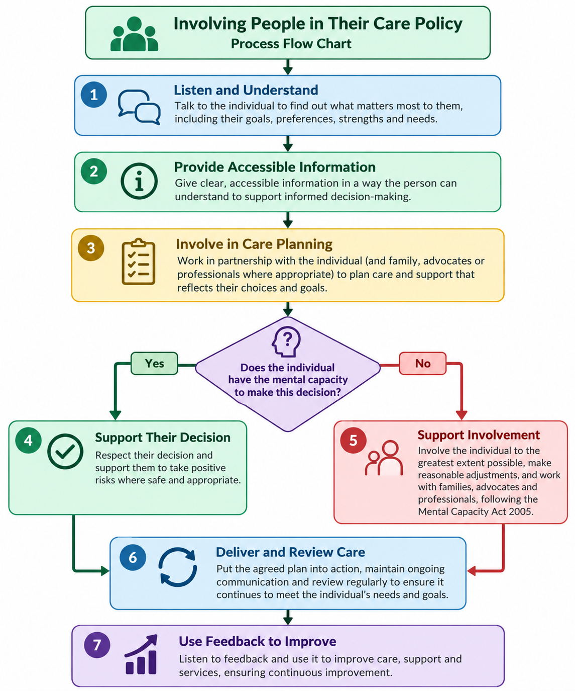

2- Involving People in Their Care Policy Easy Read

