HUMAN RIGHTS POLICY

1. Introduction
Acorns Health Care is committed to upholding, protecting and actively promoting the human rights, dignity, independence and freedoms of every person we support. Human rights are fundamental to safe, lawful, person-centred and compassionate support.

This policy sets out the values, principles and expectations that underpin Acorns Health Care’s approach to human rights. It applies across our supported living and domiciliary care services and should be read alongside the Mental Capacity Act, safeguarding, consent, equality, confidentiality and person-centred care policies.

Acorns Health Care recognises its responsibility to treat people with kindness, compassion and respect, while promoting dignity, independence, choice and control. Support must be provided with the person’s consent wherever possible and, where a person lacks capacity to make a specific decision, in accordance with the Mental Capacity Act 2005 and a lawful best-interests process.

Human rights apply equally to every person, regardless of disability, health condition, communication needs, age, circumstances, culture, beliefs or level of support required.

2. Purpose
The purpose of this policy is to ensure that human rights are embedded in everyday support and decision-making at Acorns Health Care.
Acorns Health Care is committed to promoting the rights, independence, dignity, wellbeing and inclusion of every person we support.
Where a person needs support to understand, communicate or exercise a right, staff will make reasonable adjustments and provide appropriate assistance so the person can participate as fully as possible.

3. Scope
This policy applies to all Acorns Health Care employees, managers, agency workers, volunteers, students, contractors and other people working on behalf of the organisation.
Managers are responsible for ensuring that human rights are understood and embedded within everyday practice, care planning, risk management, supervision, training, incident review and quality assurance.

4. Legal and Regulatory Framework
- Acorns Health Care will uphold human rights in accordance with relevant legislation and regulatory requirements, including:
- Human Rights Act 1998.
- Health and Social Care Act 2008 (Regulated Activities) Regulations 2014, including Regulation 13: Safeguarding Service Users from Abuse and Improper Treatment.
- Mental Capacity Act 2005 and associated Code of Practice.
- Care Act 2014.
- Equality Act 2010.
- Relevant safeguarding legislation, statutory guidance and local safeguarding procedures.

5. Understanding Human Rights

Human rights are not separate from everyday care. They should be visible in the way people are spoken to, supported, listened to and recorded.
Staff must consider the person’s rights when making decisions, providing personal care, managing risk, supporting behaviour, administering medicines, responding to incidents and planning changes to support.
A person’s disability, communication difficulty or need for substantial support does not remove their rights.

6. Rights of the People We Support

- People supported by Acorns Health Care have the right, as applicable to their circumstances, to:
- Be treated with dignity, kindness, respect and compassion.
- Be protected from abuse, neglect, improper treatment and unlawful restriction or loss of liberty.
- Choose how they want to be addressed and how others communicate with them.
- Be recognised and treated as an individual, rather than as a diagnosis, condition or task.
- Access appropriate statutory, health, social care and specialist services.
- Choose what they want to eat and drink and, wherever possible, where and when they want to eat or drink.
- Access advocacy and communication support where they need assistance to express their wishes, feelings or views.
- Have privacy in their own accommodation and during personal care and other private activities.
- Be involved in and consulted about changes to their living arrangements and support.
- Suggest improvements and provide feedback or raise concerns without fear of disadvantage.
- Have visitors of their choice, subject to any lawful and clearly documented restrictions.
- Have access to appropriate support to maintain relationships with family, friends and the wider community.
- Have a clear and fair service agreement and understand the support being provided.
- Participate in civic life, including registering and voting in elections where eligible.
- Manage their own money where they have the capacity and authority to do so.
- Mix with and participate in their local community.
- Choose their GP, dentist and other health professionals where choice is available.
- Be as independent as possible and not be subject to unnecessary or unjust restrictions on movement.

- Make choices involving reasonable risk where they have capacity to make the relevant decision.
- Have their cultural, language, religious and personal beliefs, views and needs respected.
- All staff are expected to protect and uphold these rights at all times and to facilitate access to advocacy services where a person wishes for representation but needs support to obtain it.

7. Choice, Consent and Mental Capacity

Acorns Health Care will support people to make their own decisions wherever possible. Staff must not assume that a person lacks capacity because they have a learning disability, autism, mental health condition, communication difficulty or other disability.

Where a decision-specific capacity assessment establishes that a person lacks capacity, staff must follow the Mental Capacity Act 2005. This includes supporting the person to participate as far as possible, considering their wishes and feelings, involving appropriate people and choosing the least restrictive option.

People may make decisions that others consider unwise. This does not, by itself, mean that they lack capacity.

Any restriction of a person’s rights or freedom must have a clear lawful basis, be necessary and proportionate, and be regularly reviewed.

8. Dignity, Respect and Independence

Staff must promote dignity and independence in every aspect of support. This includes:

- Knocking and seeking permission before entering a person’s private space wherever appropriate.
- Offering meaningful choices rather than making assumptions about what a person wants.
- Supporting people to do things for themselves wherever they can.
- Providing personal care discreetly and respectfully.
- Using the person’s preferred name and communication method.
- Avoiding language that labels, blames, infantilises or stereotypes the person.
- Recognising that a person’s home is their home and should be treated as such.

9. Freedom, Restrictions and Least Restrictive Practice

Acorns Health Care recognises that restrictions can have a significant impact on a person’s human rights. Restrictions must never be used simply because they are convenient for staff or because they make a service easier to manage.
Where a restriction is necessary to manage a clearly identified risk, staff and managers must consider whether there is a less restrictive alternative. The restriction should be proportionate to the risk, clearly documented and reviewed.

- Examples of restrictions requiring careful consideration include:
- Restrictions on leaving or moving around the home.
- Locked doors or restricted access to areas or belongings.
- Restrictions on contact with family, friends or the community.
- Physical restraint or other restrictive practices.
- Use of medication, including PRN medication, where its purpose or effect may restrict behaviour or freedom.
- Continuous supervision or monitoring.
- Surveillance or monitoring systems.

Where restrictions may amount to a deprivation of liberty, staff must follow the relevant Mental Capacity Act, safeguarding and legal processes and seek advice from management and appropriate statutory authorities.

10. Advocacy and Representation

Acorns Health Care will support people to have their voice heard. Staff should help people understand their rights, choices and available options and should support access to independent advocacy where appropriate.
- Family members, representatives and significant others should be involved where appropriate and lawful.
- Independent advocates should be considered where a person needs support to understand, express or participate in decisions.
- The role of attorneys, deputies and other legal representatives must be respected within the limits of their legal authority.
- The person’s own wishes, feelings, preferences and communication should remain central to decision-making.

11. Privacy and Confidentiality

Acorns Health Care recognises confidentiality as an essential part of respectful and lawful care. Staff must protect personal information and only share information where there is a lawful and appropriate reason to do so.

Staff must not voluntarily disclose information about a person to third parties unless the person has given permission or another lawful basis for disclosure applies, such as safeguarding, legal or professional requirements.

People’s privacy must also be respected in their home, during personal care, when using the telephone or internet, and when records or photographs are being created or accessed.

12. Equality, Culture, Language and Beliefs

Acorns Health Care will respect each person’s identity, culture, language, religion, beliefs, relationships, communication style and personal preferences.
Staff must not make assumptions about what a person wants or believes. Reasonable adjustments should be made so that people can understand information, communicate their wishes and participate in decisions.

Discrimination, harassment, degrading treatment or exclusion is not acceptable.

13. Communication and the Person’s Voice

People must be supported to communicate in ways that work for them. This may include speech, signs, gestures, objects of reference, communication aids, visual information, technology or behaviour as communication.

Staff should listen to what the person is communicating and seek to understand the meaning and context rather than dismissing communication because it is difficult to interpret.

Records should reflect the person respectfully and objectively, including their choices, preferences, communication and experiences.

14. Safeguarding and Protection from Abuse

Every person has the right to live free from abuse, neglect, exploitation and improper treatment.
Any concern that a person’s human rights are being breached must be taken seriously and reported through Acorns Health Care safeguarding and incident reporting procedures.
- Concerns must be reported promptly.
- Immediate safety must be considered.

- The person’s wishes, communication and rights should be considered throughout the response.
- Records must be factual, accurate, respectful and contemporaneous.
- Managers must escalate concerns to appropriate safeguarding or statutory agencies where required.

15. Changes to Living Arrangements and Support

People should be involved in decisions about changes to their home, living arrangements, staffing, routines or support wherever possible.

Changes should be discussed with the person in a way they can understand, with appropriate communication support. Their preferences, concerns and wishes should be recorded in their care plan and considered in decision-making.

Where a person lacks capacity for the relevant decision, the Mental Capacity Act and best-interests process must be followed, including consideration of less restrictive alternatives and appropriate consultation.

16. Choice and Positive Risk-Taking

Acorns Health Care recognises that independence involves making choices and taking reasonable risks. Staff must not remove a person’s opportunities simply because there is some risk.

Where a person has capacity to make the relevant decision, their decision should normally be respected even where others would make a different choice. Where a person lacks capacity, risks should be considered as part of a lawful best-interests process.

Risk assessments should balance safety with the person’s rights, independence, quality of life and preferences.

17. Staff Roles and Responsibilities

All staff are responsible for protecting and promoting human rights. Staff must:
- Treat people with dignity, kindness and respect.
- Promote choice, control and independence.
- Seek consent and support decision-making.
- Follow the Mental Capacity Act where a person may lack capacity.
- Avoid unnecessary, disproportionate or discriminatory restrictions.
- Respect privacy and confidentiality.
- Recognise and report safeguarding concerns.
- Use respectful, person-centred language.
- Record concerns, decisions and actions accurately.
- Raise concerns if organisational practice appears to conflict with a person’s rights.

18. Managers’ Responsibilities

Managers are responsible for ensuring that human rights are embedded in day-to-day practice. This includes:
- Ensuring care plans and risk assessments reflect the person’s rights, choices and preferences.
- Reviewing restrictions and considering whether they remain necessary and proportionate.
- Ensuring staff understand consent, capacity, safeguarding and confidentiality.
- Responding to complaints, concerns and incidents.
- Escalating safeguarding or legal concerns appropriately.
- Ensuring advocacy is considered where appropriate.
- Using supervision, audits and quality assurance to monitor practice.

19. Training
All staff will receive training and guidance to recognise and uphold human rights and to understand confidentiality and related responsibilities.
Human rights learning will be incorporated into induction and ongoing development, including relevant Care Certificate standards such as:

- Duty of Care.
- Equality and Diversity.
- Privacy and Dignity.
- Awareness of Mental Health, Dementia and Learning Disability.
- Safeguarding Adults.
- Safeguarding Children.
- Handling Information.

Additional training will be provided where staff have specific responsibilities relating to mental capacity, safeguarding, restrictive practices, advocacy or information governance.

20. Documentation and Record Keeping

Records relating to human rights, consent, capacity, restrictions, safeguarding, advocacy and significant decisions must be accurate, respectful, relevant and up to date.

Records should demonstrate what the person wanted, what support was offered, what decision was made, why it was made and how the person’s rights were considered.
Information must be stored and shared securely in accordance with organisational information governance requirements.

21. Monitoring and Governance

- Acorns Health Care will monitor compliance through:
- Care plan and risk assessment audits.
- Safeguarding and incident reviews.
- Mental Capacity and best-interests documentation reviews.
- Review of restrictive practices.
- Supervision and competency checks.
- Feedback and complaints.
- Quality assurance activity and organisational learning.
- Learning from concerns, incidents, feedback and audits will be used to improve practice and protect people’s rights.

22. Complaints, Feedback and Raising Concerns

People have the right to raise concerns, make complaints and suggest improvements. They must not be disadvantaged because they have raised a concern.

Staff must support people to access the complaints process and advocacy where required. Concerns about abuse, neglect, unlawful restrictions or serious breaches of rights must also be managed through safeguarding and incident procedures where appropriate.

23. Review

This policy will be reviewed biannually or sooner if required to reflect changes in legislation, guidance, case law, regulatory requirements or organisational practice.
The policy should be read alongside Acorns Health Care policies and procedures relating to Mental Capacity, Consent, Safeguarding, Equality and Diversity, Confidentiality, Person-Centred Care and Deprivation of Liberty.

Version | 2
Date Reviewed | 03.10.2026
Policy Owner | Nominated Individual
Next Review Date | 02.10.2028
Review Frequency | Biannually
Applies To | Employees, Bank and Agency staff

Appendices;

1 – Human Rights Policy Flow Chart

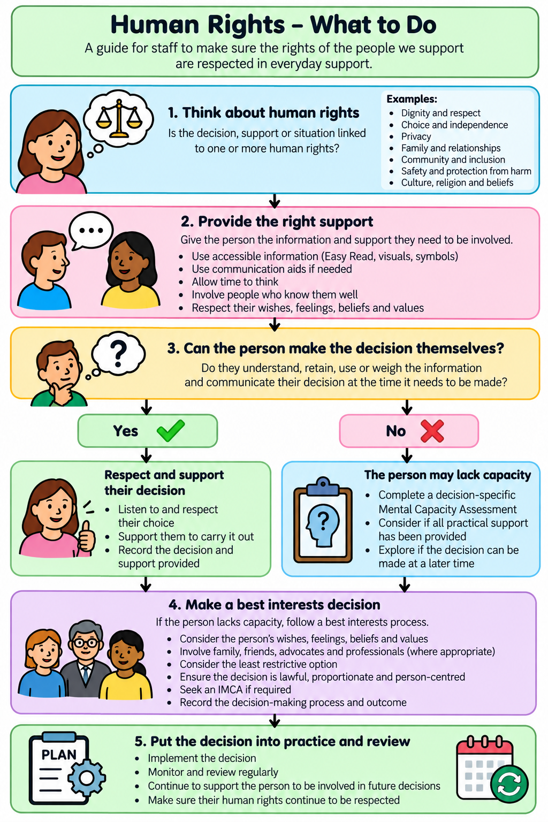

2– Human Rights Policy Easy Read

