Equality, Diversity and Human Rights Policy

1.Introduction
At Acorns Health Care, we are committed to creating an inclusive culture where every individual is treated with dignity, compassion, fairness and respect. We believe that equality, diversity, inclusion and the protection of human rights are fundamental to delivering high-quality, person-centred care and support. These principles underpin every aspect of our organisation, influencing the way we recruit and support our workforce, engage with people who use our services, and develop positive relationships with families, professionals and the wider community.
We recognise that every individual is unique, bringing their own experiences, abilities, beliefs, values, aspirations and identity. By embracing diversity and promoting inclusion, we aim to ensure that every person feels valued, listened to and empowered to make choices about their own lives. We are committed to removing barriers that may prevent individuals from participating fully in society and ensuring that our services are accessible, responsive and tailored to meet individual needs.
As a provider of supported living and domiciliary care services, Acorns Health Care recognises its legal and ethical responsibilities under the Equality Act 2010, the Human Rights Act 1998, the Care Act 2014, the Mental Capacity Act 2005 and the Health and Social Care Act 2008 (Regulated Activities) Regulations 2014. We are committed to promoting equality of opportunity, preventing discrimination and ensuring that the rights, freedoms and dignity of every individual are upheld in all aspects of service delivery.
We recognise that equality is not about treating everyone the same; it is about recognising individual differences and making reasonable adjustments so that every person has equitable opportunities to achieve positive outcomes. Our approach is founded on person-centred values, positive risk-taking, inclusion and the belief that people should be supported to exercise choice, maintain independence and live fulfilling lives within their local communities.
This policy reflects the expectations of the Care Quality Commission (CQC) Single Assessment Framework and demonstrates our commitment to delivering services that are safe, effective, caring, responsive and well-led. It applies to all employees, volunteers, agency workers, contractors, people we support, families and anyone acting on behalf of Acorns Health Care.

2. Purpose
The purpose of this policy is to ensure that equality, diversity, inclusion and human rights are embedded throughout every aspect of Acorns Health Care's services and organisational culture.
The policy aims to:
- Promote equality of opportunity for everyone accessing or working within Acorns Health Care.
- Ensure that every individual is treated fairly, respectfully and without discrimination.
- Promote an inclusive culture where diversity is recognised, valued and celebrated.
- Protect the human rights, dignity, privacy and independence of the people we support.
- Eliminate discrimination, harassment, bullying and victimisation.
- Support staff to recognise and challenge inequality and discriminatory practice.
- Ensure services are accessible and responsive to individual needs.
- Meet the requirements of current legislation, national guidance and CQC regulations.
- Promote continuous learning and improvement in equality, diversity and inclusive practice.

3. Scope
This policy applies to:
- All people supported by Acorns Health Care.
- Employees, including permanent, temporary, bank and agency staff.
- Volunteers, apprentices and students.
- Registered Managers and members of the Senior Leadership Team.
- Directors and the Nominated Individual.
- Contractors, consultants and external professionals working on behalf of Acorns Health Care.
- Families, advocates and representatives where appropriate.
The principles contained within this policy apply throughout every stage of service delivery, recruitment, employment, management, governance and quality assurance.

4. Policy Statement
Acorns Health Care is committed to providing services that promote equality, respect diversity and uphold the human rights of every individual.
We believe that everyone has the right to:
- Be treated with dignity and respect.
- Be valued as an individual.
- Live free from discrimination, abuse and harassment.
- Make choices about their own lives wherever possible.
- Participate in decisions affecting them.
- Receive safe, person-centred care that reflects their individual needs, wishes and aspirations.
- Access services on an equal basis.
- Be supported to achieve the best possible quality of life.
We will never tolerate discrimination, victimisation, bullying, harassment or unfair treatment based upon any protected characteristic or personal circumstance.
Equality, diversity and inclusion are everyone's responsibility and form part of everyday practice across Acorns Health Care.

5. Our Commitment to Equality, Diversity, Inclusion and Human Rights
Acorns Health Care is committed to creating environments where people feel safe, respected, included and able to be themselves.
We will:
- Promote fairness, dignity and respect in every interaction.
- Recognise and value diversity as a strength.
- Deliver care that reflects each person's individual identity, preferences and aspirations.
- Remove barriers that prevent equal participation.
- Make reasonable adjustments to support accessibility and inclusion.
- Encourage independence, choice and positive risk-taking.
- Promote participation in community life and meaningful activities.
- Challenge discrimination and prejudice whenever it occurs.
- Foster a workplace where employees are treated fairly and have equal opportunities to develop and succeed.
- Continuously review our practices to ensure they remain inclusive, equitable and person-centred.
Our commitment extends beyond legal compliance. We strive to create a culture where diversity is celebrated, inclusion is actively promoted and human rights are embedded within everyday practice.

6. Equality, Diversity and Inclusion
Equality means ensuring that every individual has fair access to opportunities, services and support. It recognises that some people may require different approaches or reasonable adjustments to achieve equitable outcomes.
Diversity acknowledges and values the differences between individuals, including differences in age, disability, ethnicity, culture, language, religion, belief, gender identity, sexual orientation, lived experience, socio-economic background and personal circumstances. These differences enrich our organisation and strengthen the quality of care we provide.
Inclusion is about creating environments where everyone feels welcomed, respected and able to participate fully. It means ensuring that people are listened to, involved in decisions that affect them and supported to achieve their goals without unnecessary barriers.

Acorns Health Care is committed to promoting equality, valuing diversity and fostering inclusion in every aspect of our services. We recognise that inclusive practice improves wellbeing, promotes independence, enhances relationships and contributes to better outcomes for the people we support.
Our approach is underpinned by person-centred values, recognising that every individual has the right to be treated as an equal partner in planning and delivering their care and support.

7. Human Rights in Everyday Practice
At Acorns Health Care, we recognise that equality and human rights are inseparable. Human rights are not simply legal obligations but fundamental principles that shape the way we provide care, support and services. Every person has the right to live with dignity, autonomy, privacy and respect, regardless of their age, disability, background or personal circumstances.
We are committed to ensuring that our policies, procedures and everyday practice uphold the rights protected under the Human Rights Act 1998. Staff are expected to understand how these rights apply in practice and to ensure that every decision made is lawful, proportionate and person centred.
In delivering care and support, Acorns Health Care will protect and promote:
- The right to life.
- Freedom from torture, inhuman or degrading treatment.
- The right to liberty and security.
- The right to respect for private and family life.
- Freedom of thought, conscience and religion.
- Freedom of expression.
- Freedom of association.
- The right to marry and establish relationships where appropriate.
- Protection from discrimination in the enjoyment of all rights.
Staff will always seek the least restrictive approach when supporting individuals and will ensure that restrictions are only implemented where they are lawful, necessary, proportionate and in the person's best interests.
Everyday practice should promote dignity, privacy, independence and choice while balancing individual rights with the safety and wellbeing of the person and others.

8. Protected Characteristics
Acorns Health Care is committed to eliminating discrimination and promoting equality in accordance with the Equality Act 2010.

We recognise and respect the protected characteristics identified within the legislation:
- Age.
- Disability.
- Gender reassignment.
- Marriage and civil partnership.
- Pregnancy and maternity.
- Race, including colour, nationality and ethnic origin.
- Religion or belief.
- Sex.
- Sexual orientation.
No individual will receive less favourable treatment because of any protected characteristic or because they are associated with someone who has a protected characteristic.
We also recognise that discrimination may occur because of additional factors including:
- Socio-economic circumstances.
- Caring responsibilities.
- Neurodiversity.
- Communication differences.
- Mental ill health.
- Homelessness.
- Previous care experience.
- Lifestyle choices.
- Appearance or personal identity.
Although these characteristics may not all be protected under legislation, Acorns Health Care believes every individual deserves to be treated fairly, respectfully and without prejudice.

9. Person-Centred and Inclusive Care
Providing person-centred care means recognising that every individual has unique strengths, preferences, aspirations and support needs. Equality is achieved by understanding these differences and tailoring care accordingly, rather than treating everyone in the same way.
Staff will work collaboratively with the people they support to develop care and support plans that reflect what matters most to them.
Care planning will consider:
- Individual wishes and preferences.
- Cultural identity and heritage.
- Religious or spiritual beliefs.
- Communication needs.
- Relationships and family involvement.
- Gender identity and preferred pronouns.
- Sexual orientation where relevant to care and wellbeing.
- Health needs and disabilities.
- Sensory needs.
- Daily routines and lifestyle choices.
- Employment, education and meaningful occupation.
- Community participation.
- Personal goals and future aspirations.
People will be supported to make decisions about their own lives wherever possible.
Where an individual lacks capacity to make a specific decision, staff will act in accordance with the Mental Capacity Act 2005, ensuring that decisions are made in the person's best interests using the least restrictive option available.
Person-centred care plans will be reviewed regularly and whenever an individual's needs or circumstances change.

10. Accessible Communication and Reasonable Adjustments
Effective communication is essential to promoting equality, inclusion and person-centred care.
Acorns Health Care is committed to ensuring that information is provided in ways that people can understand and use.
Reasonable adjustments may include:
- Easy Read information.
- Large print documents.
- Audio formats.
- Picture or symbol-based communication.
- Communication passports.
- British Sign Language interpreters.
- Translation services.
- Assistive technology.
- Visual timetables.
- Social stories.
- Accessible digital information.

Staff will identify and record communication needs during assessment and ensure these needs are reflected within care planning.
Communication methods will be reviewed regularly to ensure they continue to meet individual needs.
The organisation will comply with the NHS Accessible Information Standard where applicable and will ensure that people receive information in a format that supports informed decision-making.

11. Equality in Service Delivery
Acorns Health Care is committed to providing services that are equitable, responsive and accessible to everyone.
We will ensure that:
- People have equal access to assessment, care and support.
- Decisions are based upon assessed needs rather than assumptions or stereotypes.
- Services are delivered fairly and consistently.
- Individuals are supported to participate fully in planning and reviewing their care.
- Barriers to accessing services are identified and reduced wherever possible.
- Reasonable adjustments are made to enable equitable participation.
- Care is delivered in a culturally sensitive and respectful manner.
- Individuals are supported to maintain relationships, community connections and meaningful activities.
We recognise that achieving equality sometimes requires different approaches for different people. Staff should therefore adopt flexible, creative and person-centred approaches that enable individuals to achieve the same opportunities and outcomes as others.
We will continually review our services to ensure they remain inclusive, responsive and reflective of the diverse communities we support.

12. Equality in Employment
Acorns Health Care is committed to being an inclusive employer that values diversity and promotes equality throughout the employment journey. We recognise that a diverse workforce brings a wealth of knowledge, experience and perspectives that enhance the quality of care we provide.
All employment decisions will be based on merit, competence and organisational need, ensuring that individuals are treated fairly and consistently throughout recruitment, induction, training, development and career progression.

The organisation will ensure that:
- Recruitment and selection processes are fair, transparent and free from discrimination.
- Job advertisements, interviews and assessment processes are accessible and inclusive.
- Reasonable adjustments are made during recruitment and employment where required.
- Employees have equal access to learning, development and promotion opportunities.
- Staff are treated fairly regardless of age, disability, race, religion or belief, sex, sexual orientation, gender reassignment, pregnancy or maternity, marriage or civil partnership status, or any other protected characteristic.
- Employment decisions are based upon objective criteria and organisational requirements.
- Flexible working requests are considered fairly and in accordance with organisational policies and employment legislation.
- Employees feel safe to express their identity and raise concerns without fear of discrimination or victimisation.
Acorns Health Care is committed to fostering a respectful workplace where everyone feels valued, supported and able to contribute to the organisation's success.

13. Zero Tolerance of Discrimination, Harassment and Victimisation
Acorns Health Care operates a zero-tolerance approach to discrimination, harassment, bullying, victimisation and hate incidents. Such behaviour is incompatible with our values and will not be accepted under any circumstances.
This applies to:
- Employees.
- Agency and bank workers.
- Volunteers.
- Contractors.
- Visitors.
- Professionals working alongside Acorns Health Care.
- People using our services, where appropriate and in accordance with their assessed needs.
Examples of unacceptable behaviour include, but are not limited to:
- Direct or indirect discrimination.
- Harassment relating to a protected characteristic.
- Bullying or intimidating behaviour.
- Offensive language or jokes.
- Racist, sexist, homophobic, transphobic or discriminatory comments.
- Excluding individuals because of personal characteristics.
- Victimising someone who has raised a concern.
- Hate incidents or hate crime.

- Online or social media harassment connected with employment or service delivery.
Where concerns are identified, Acorns Health Care will:
- Take all reports seriously.
- Respond promptly and proportionately.
- Ensure individuals feel safe and supported.
- Record concerns accurately.
- Undertake a fair and objective investigation.
- Implement appropriate safeguarding measures where required.
- Take disciplinary action where appropriate.
- Share learning to reduce the likelihood of recurrence.
Behaviour that may be linked to a person's disability, communication needs, mental health condition or other assessed support needs will be responded to sensitively and in accordance with their Positive Behaviour Support Plan, Mental Capacity Act principles and person-centred care plan. This does not lessen the impact on others but ensures that responses are appropriate, proportionate and focused on understanding and meeting the person's needs.

14. Safeguarding and Human Rights
Protecting people from abuse, neglect, discrimination and exploitation is a fundamental responsibility of Acorns Health Care.
The organisation recognises that discriminatory abuse is a form of abuse under the Care Act 2014 and may include:
- Harassment based on protected characteristics.
- Hate crime.
- Humiliating or degrading treatment.
- Racist or discriminatory language.
- Unequal access to services.
- Deliberate exclusion from activities or opportunities.
- Failure to make reasonable adjustments.
- Unlawful restrictions on rights and freedoms.
All safeguarding concerns will be managed in accordance with the Acorns Health Care Safeguarding Adults Policy and local safeguarding procedures.
Where concerns arise, staff must:
- Take immediate action to ensure the person's safety.
- Report concerns to their manager without delay.
- Complete appropriate incident and safeguarding documentation.

- Preserve evidence where necessary.
- Escalate concerns to the Local Authority, Police, Integrated Care Board or Care Quality Commission where required.
- Work collaboratively with partner agencies to safeguard individuals.
Safeguarding responses will always seek to uphold the individual's rights, wishes and best interests while promoting safety, dignity and wellbeing.

15. Raising Concerns, Complaints and Speaking Up
Acorns Health Care promotes a culture of openness, honesty and transparency where individuals feel confident to raise concerns without fear of blame or reprisal.
People we support, families, advocates, professionals, visitors and employees are encouraged to speak up if they experience or witness discrimination, inequality, harassment or any practice that compromises dignity or human rights.
Concerns may be raised through:
- Speaking with a member of staff or manager.
- The Acorns Health Care Complaints Procedure.
- The Compliments and Feedback Process.
- The Whistleblowing Policy.
- Safeguarding procedures.
- External organisations where appropriate.
All concerns will be:
- Listened to respectfully.
- Taken seriously.
- Investigated fairly and impartially.
- Managed confidentially wherever possible.
- Responded to within agreed timescales.
- Used as opportunities for organisational learning and service improvement.
No individual will suffer detriment or victimisation for raising a genuine concern in good faith.

16. Roles and Responsibilities

The Nominated Individual and Senior Leadership Team
The Nominated Individual and Senior Leadership Team are responsible for:
- Promoting an organisational culture that values equality, diversity, inclusion and human rights.
- Ensuring adequate governance arrangements are in place.
- Monitoring compliance with legislation and regulatory requirements.
- Providing sufficient resources to implement this policy.
- Reviewing organisational performance and driving continuous improvement.

Registered Managers
Registered Managers are responsible for:
- Implementing this policy within their service.
- Leading by example and promoting inclusive practice.
- Supporting staff through support session, appraisal and training.
- Addressing concerns promptly and appropriately.
- Monitoring equality-related incidents, complaints and safeguarding concerns.
- Ensuring care planning reflects individual needs, preferences and protected characteristics where appropriate.
- Promoting positive relationships with families, advocates and professionals.

Employees
Every employee has a responsibility to:
- Treat everyone with dignity, courtesy and respect.
- Promote equality and inclusion in everyday practice.
- Respect diversity and individual differences.
- Challenge discriminatory language or behaviour appropriately.
- Support people to exercise choice and maintain independence.
- Report concerns relating to discrimination, abuse or inequality.
- Maintain professional boundaries.
- Complete mandatory training and keep knowledge up to date.
- Reflect on their own attitudes, behaviours and unconscious bias to ensure these do not adversely affect the care and support they provide.
Employees are expected to uphold the values of Acorns Health Care at all times and to contribute positively to an inclusive, respectful and compassionate culture.

17. Training and Competency
Acorns Health Care is committed to ensuring that all employees have the knowledge, skills and confidence to promote equality, diversity, inclusion and human rights in every aspect of their role. We recognise that creating an inclusive culture requires ongoing learning, reflection and professional development.
All employees will receive training appropriate to their role, enabling them to understand both their legal responsibilities and the practical application of equality and human rights within health and social care.
Mandatory training will include, where appropriate:
- Equality, Diversity and Inclusion.
- Human Rights and the Human Rights Act 1998.
- Equality Act 2010 and protected characteristics.
- Person-Centred Care.
- Mental Capacity Act 2005 and supported decision-making.
- Safeguarding Adults.
- Accessible communication and the Accessible Information Standard.
- Recognising and responding to discrimination, harassment, bullying and victimisation.
- Professional values, dignity and respect.
- Cultural awareness and inclusive practice.
- Unconscious bias and reflective practice.
Training will be provided as part of the organisation's induction programme and refreshed in accordance with organisational requirements, legislation and best practice guidance.
Managers will support staff development through:
- Regular support session and reflective discussions.
- Competency assessments.
- Observation of practice.
- Team meetings.
- Reflective learning following incidents or complaints.
- Continuous professional development opportunities.
Where learning or competency needs are identified, additional coaching, support sessions or training will be provided to ensure staff remain competent to deliver safe, inclusive and person-centred care.

18. Record Keeping and Confidentiality
Accurate, respectful and objective record keeping is essential to promoting equality, protecting human rights and delivering high-quality care.
All records must:
- Be accurate, factual and contemporaneous.
- Use respectful, inclusive and person-centred language.
- Reflect individual wishes, preferences and protected characteristics where relevant to care.
- Record any reasonable adjustments or communication needs.
- Document concerns relating to discrimination, harassment or inequality.
- Record actions taken following incidents, complaints or safeguarding concerns.
- Be stored securely in accordance with organisational procedures.
- Comply with the Data Protection Act 2018 and UK General Data Protection Regulation (UK GDPR).
Information relating to equality, diversity or personal identity will only be shared where there is a lawful basis to do so and where it is necessary to support safe and effective care or to meet safeguarding, regulatory or legal requirements.
All employees have a responsibility to maintain confidentiality and respect each person's right to privacy.

19. Governance, Monitoring and Continuous Improvement
Acorns Health Care is committed to promoting a culture of equality, diversity, inclusion and continuous improvement. Compliance with this policy will be monitored to ensure that equality, diversity and human rights remain central to the delivery of safe, effective, caring, responsive and well-led services.
The organisation will monitor compliance through:
- Quality assurance audits.
- Care plan and documentation reviews.
- Equality impact considerations.
- Support sessions and competency assessments.
- Staff, family and stakeholder feedback.
- Complaints, compliments and concerns.
- Safeguarding and incident reviews.
- Workforce monitoring and equality data where appropriate.
- Internal governance meetings.
- External inspections and regulatory visits.

Learning identified through audits, incidents, complaints, safeguarding reviews, feedback or changes in legislation will be used to strengthen practice, improve service quality and promote an inclusive organisational culture.
Acorns Health Care encourages a culture of openness and continuous learning, where feedback is valued and improvements are implemented to enhance outcomes for the people we support and our workforce.

20. Associated Policies
This policy should be read alongside the following Acorns Health Care policies:
- Autonomy, Choice and Independence Policy
- Person-Centred Care Policy
- Safeguarding Adults Policy
- Mental Capacity Act 2005 Policy
- Positive Behaviour Support Policy
- Accessible Information Policy
- Complaints Policy
- Dignity at Work and Anti-Bullying Policy
- Whistleblowing Policy
- Recruitment and Selection Policy
- Learning and Development Policy
- Confidentiality Policy
- Record Keeping Policy
- Data Protection and Information Governance Policy
- Health and Safety Policy

21. Legislation and Guidance
This policy has been developed with reference to the following legislation and best practice guidance:
- Equality Act 2010.
- Human Rights Act 1998.
- Health and Social Care Act 2008 (Regulated Activities) Regulations 2014.
- Care Act 2014.
- Mental Capacity Act 2005 and Code of Practice.
- Data Protection Act 2018.
- UK General Data Protection Regulation (UK GDPR).
- Accessible Information Standard (NHS England).
- Care Quality Commission Single Assessment Framework.
- Skills for Care guidance on Equality, Diversity and Inclusion.
- NICE guidance relevant to equality, inclusion and person-centred care.
Acorns Health Care will review its practices regularly to ensure continued compliance with current legislation, national guidance and regulatory expectations.

22. Policy Review
This policy will be reviewed biannually, or sooner where required, to ensure that it remains current, effective and reflective of legislative, regulatory and organisational developments.
An earlier review may be required following:
- Changes in legislation or statutory guidance.
- Updates to Care Quality Commission requirements.
- Learning from audits, inspections, safeguarding concerns or complaints.
- Significant organisational changes.
- Changes to best practice guidance.
- Feedback from people we support, families, employees or partner organisations.
Responsibility for reviewing this policy rests with the Nominated Individual, in consultation with the Senior Leadership Team, Registered Managers and other relevant stakeholders.
Any amendments will be communicated to employees through the organisation's policy management process and incorporated into induction, mandatory training, support sessions and quality assurance activities.

23. Conclusion
Acorns Health Care believes that equality, diversity, inclusion and respect for human rights are fundamental to delivering outstanding care. By embracing individuality, promoting fairness and removing barriers to participation, we empower the people we support to live fulfilling, independent and meaningful lives.

Version | 3
Date Reviewed | 04.10.2026
Policy Owner | Nominated Individual
Next Review Date | 03.07.2028
Review Frequency | Biannually
Applies To
  People we support, employees, bank and agency workers, volunteers, contractors, professionals, families, advocates and visitors

Appendices;

1-Equality, Diversity and Human Rights Policy Flow Chart

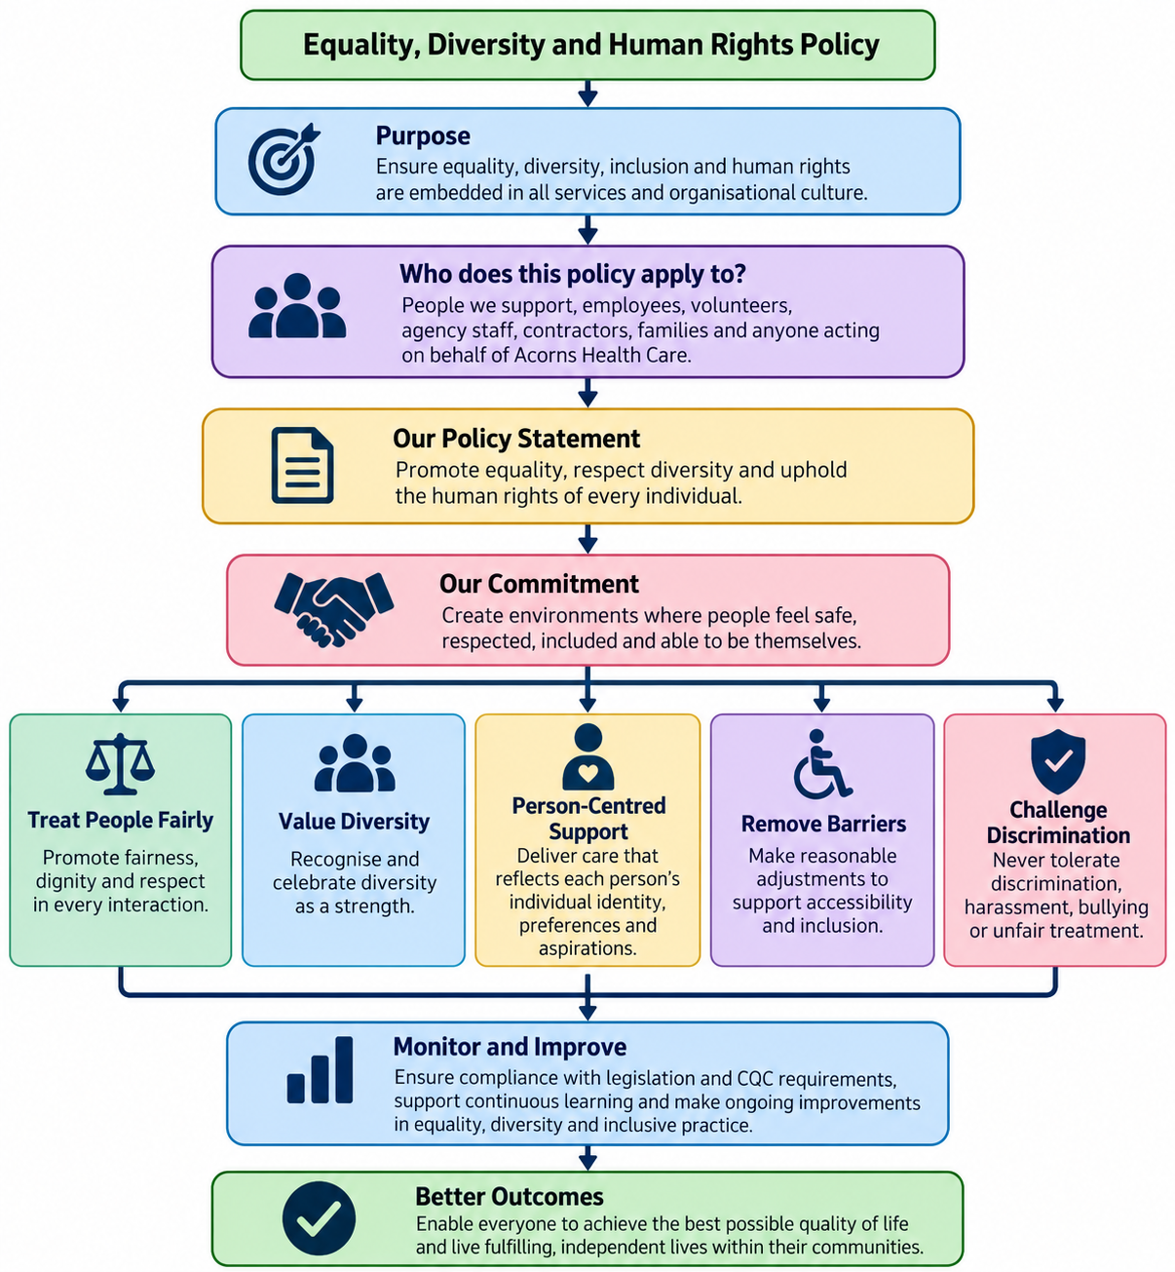

2- Equality, Diversity and Human Rights Policy Easy Read

