Autonomy, Choice and Independence in Supported Living Policy

1. Introduction
At Acorns Health Care, we believe that every person has the right to live a life that reflects their own wishes, preferences, values and aspirations. We are committed to providing person-centred support that promotes autonomy, choice and independence, enabling individuals to exercise control over their lives while receiving the support they need to remain safe, healthy and well.
Supported living is founded on the principle that people have the same legal rights, freedoms and responsibilities as everyone else. Individuals receiving support are tenants in their own homes and should be empowered to make decisions about where they live, how they spend their time, who supports them and the goals they wish to achieve.
We recognise that independence looks different for every person. For some, it may involve managing finances or travelling independently, while for others it may mean making everyday decisions with appropriate support. Our role is to maximise each person's opportunities, abilities and confidence rather than focusing on limitations.
Acorns Health Care adopts a strengths-based approach, recognising that people develop skills, confidence and resilience through making choices and experiencing positive risk-taking. We will always seek to balance an individual's right to make decisions with our duty to provide safe, high-quality care and support.
Where individuals require support to make decisions, we will work in accordance with the Mental Capacity Act 2005, ensuring that every effort is made to maximise capacity and that any decisions made on behalf of an individual are lawful, proportionate and made in their best interests.
We are committed to protecting and promoting the human rights of everyone we support. This includes respecting dignity, privacy, equality, diversity, culture, relationships, identity and the right to participate fully in community life. Restrictions on an individual's rights will only ever be implemented where there is a lawful justification, a clear risk of harm and where the least restrictive option has been identified.
This policy sets out how Acorns Health Care promotes autonomy, choice and independence throughout all supported living services and demonstrates our commitment to delivering safe, effective, compassionate and high-quality support in accordance with legislation, best practice and the Care Quality Commission's Single Assessment Framework.

2. Purpose
The purpose of this policy is to ensure that every individual supported by Acorns Health Care is empowered to make informed choices, maintain control over their own life and achieve the greatest possible level of independence.
This policy aims to:
- Promote autonomy and self-determination.
- Support individuals to make informed choices.
- Encourage independence in all aspects of daily living.
- Protect the legal and human rights of individuals.
- Promote positive risk-taking through person-centred planning.
- Ensure decisions are made in accordance with the Mental Capacity Act 2005 where appropriate.
- Provide staff with clear guidance on promoting independence while maintaining safety.
- Ensure compliance with relevant legislation and CQC expectations.

3. Scope
This policy applies to:
- All individuals supported by Acorns Health Care.
- Permanent employees.
- Bank and agency staff.
- Volunteers.
- Students.
- Registered Managers.
- Regional Managers.
- Directors and Senior Leadership Team.
The principles contained within this policy apply across every Acorns Health Care supported living service and should be read alongside policies relating to:
- Person-Centred Care
- Mental Capacity Act
- Safeguarding Adults
- Positive Behaviour Support
- Risk Assessment
- Equality, Diversity and Inclusion
- Complaints
- Privacy and Confidentiality

4. Policy Statement
Acorns Health Care is committed to creating environments where people are empowered to live the lives they choose.
We believe every individual has the right to:
- Be treated with dignity and respect.
- Make decisions about their own life.
- Be involved in all decisions affecting them.
- Take positive risks.
- Have privacy within their own home.
- Maintain relationships with family, friends and partners.
- Access education, employment and meaningful activities.
- Participate in their local community.
- Receive information in a format they understand.
- Be supported to develop new skills and independence.
We recognise that promoting independence does not mean withdrawing support. Instead, it means providing the right support, at the right time, in a way that enables individuals to remain in control of their own lives.
All care and support provided by Acorns Health Care will be based on the principles of person-centred care, least restrictive practice, equality, inclusion and respect for individual rights.

5. Our Understanding of Autonomy, Choice and Independence
Autonomy is the ability to make decisions about one's own life and have those decisions respected.
Choice means having genuine options and the freedom to decide between them without unnecessary influence or restriction.
Independence refers to an individual's ability to carry out activities, make decisions and participate in everyday life with the level of support that best meets their needs.
At Acorns Health Care, these principles are central to everything we do.
People should be supported to decide:
- Where and how they live.
- Their daily routines.
- Their personal care preferences.
- What they eat and drink.

- How they spend their time.
- Who they spend time with.
- Their cultural, religious and spiritual practices.
- Their healthcare decisions.
- Their education, employment or volunteering opportunities.
- Their finances where appropriate.
- Their personal relationships.
- How they decorate and personalise their home.
- Their goals, aspirations and future plans.
Staff should never assume that a person's disability limits their ability to make decisions. Instead, every effort should be made to maximise participation through accessible communication, patience, encouragement and appropriate support.

6. Our Approach
Acorns Health Care promotes a culture where individuals are listened to, respected and empowered.
We will:
- Treat every person as an individual.
- Focus on strengths rather than limitations.
- Encourage independence in everyday activities.
- Promote confidence through positive encouragement.
- Respect people's rights to make informed choices.
- Support people to understand the consequences of decisions.
- Encourage positive risk-taking.
- Remove unnecessary barriers to independence.
- Ensure support is flexible and responsive.
- Review care regularly to reflect changing needs and aspirations.
Staff should always ask:
"How can I support this person to do this for themselves?"
rather than
"How can I do this for them?"
This approach promotes dignity, confidence, skill development and long-term independence.

7. Supported Living and Tenancy Rights
Acorns Health Care recognises that individuals living within our supported living services are tenants with the same legal rights and responsibilities as any other person renting their home. Our role is to provide care and support that enables individuals to live independently while respecting their rights, privacy and personal choices.
Every individual will be supported to understand:
- Their tenancy agreement.
- Their rights and responsibilities as a tenant.
- How to access support regarding housing issues.
- How rent, utilities and other financial commitments are managed.
- Who to contact regarding repairs or maintenance.
- Their rights to privacy within their home.
- Their right to receive visitors and maintain relationships.
- Their right to make decisions about their living environment.
Staff will never impose unnecessary restrictions on how individuals choose to live within their home unless there is a lawful and proportionate reason to do so.
Individuals will be encouraged to personalise their home, make decisions about furnishings and decorations, and develop a sense of ownership and belonging.

8. Preparing for Supported Living
Moving into supported living is a significant life event. Acorns Health Care will ensure that individuals are supported to make informed decisions before moving into a service.
Where possible, individuals will be offered opportunities to:
- Visit the property.
- Meet staff.
- Meet existing tenants where appropriate.
- Spend time becoming familiar with the environment.
- Receive accessible information about the service.
- Discuss any concerns or preferences.
- Understand tenancy arrangements.
- Plan how they wish to furnish and personalise their home.
Information will be provided in formats appropriate to the individual's communication needs, including Easy Read, pictorial information or alternative communication methods where required.

Families, advocates and professionals will be involved where appropriate, while ensuring the individual's wishes remain central to all decisions.

9. Promoting Choice in Care and Support
Individuals should be supported to make choices about every aspect of their daily lives.
This includes choices relating to:
- When they wake up and go to bed.
- Personal care routines.
- Clothing.
- Meals and drinks.
- Shopping.
- Household tasks.
- Leisure activities.
- Holidays.
- Visitors.
- Relationships.
- Employment, education or volunteering.
- Religious and cultural practices.
- Healthcare appointments.
- Medication, where appropriate.
- Community activities.
- How support is delivered.
Staff should avoid making assumptions or routinely making decisions on behalf of individuals.
Where a person declines support or makes a choice that carries some level of risk, staff should explore the reasons, provide information and support informed decision-making rather than immediately restricting choice.

Care should always be flexible and adapted around the individual rather than expecting individuals to fit around the service.

10. Person-Centred Care Planning
Care planning should reflect what matters most to the individual rather than focusing solely on assessed needs.
Every care plan should:
- Be developed with the individual.
- Reflect their wishes, goals and aspirations.
- Identify strengths as well as support needs.
- Promote independence.
- Encourage skill development.
- Identify meaningful outcomes.
- Include communication preferences.
- Reflect cultural, religious and lifestyle choices.
- Promote positive risk-taking.
- Be reviewed regularly.
Care plans should clearly demonstrate how staff will enable the individual to remain as independent as possible rather than creating dependency.
Staff should continually look for opportunities to reduce support where appropriate by helping individuals develop confidence and new skills.

11. Consent and Decision Making
Valid consent must always be obtained before providing care, treatment or support.
Consent must be:
- Given voluntarily.
- Informed.
- Specific to the decision.
- Given by someone with capacity.
Staff should ensure individuals:
- Receive information they understand.
- Have sufficient time to consider decisions.
- Are able to ask questions.
- Understand the consequences of their choices.

Individuals have the right to refuse care, treatment or support, even where others disagree with their decision, provided they have the capacity to make that decision.
Consent should be reviewed whenever circumstances change.

12. Mental Capacity and Best Interest Decisions
Acorns Health Care is committed to ensuring that every individual is presumed to have capacity unless it is established otherwise.
Where there are concerns regarding an individual's capacity to make a specific decision, staff must follow the principles of the Mental Capacity Act 2005.
This includes:
- Presuming capacity.
- Providing all practicable support before concluding a person lacks capacity.
- Recognising that making an unwise decision does not indicate a lack of capacity.
- Ensuring decisions made on behalf of an individual are in their best interests.
- Choosing the least restrictive option available.
Capacity assessments must:
- Be decision specific.
- Be completed by appropriately trained professionals.
- Be fully documented.
- Be reviewed where circumstances change.
Where required, Best Interest meetings should involve:
- The individual wherever possible.
- Family members.
- Attorneys or Deputies.
- Advocates.
- Relevant health and social care professionals.

Independent Mental Capacity Advocates (IMCAs) will be instructed where required by legislation.

13. Positive Risk-Taking
Acorns Health Care recognises that opportunities for learning, development and independence often involve an element of risk.
We believe that avoiding all risk can reduce quality of life and prevent individuals from achieving their goals.
Positive risk-taking involves balancing an individual's right to make choices with the need to minimise foreseeable harm.
Staff should:
- Encourage informed decision-making.
- Discuss potential risks openly.
- Identify practical ways to reduce risks.
- Promote confidence and independence.
- Review risks regularly.
- Learn from incidents and near misses.
Risk assessments should never be used simply to prevent people from doing things.
Instead, they should identify how activities can be undertaken as safely as reasonably possible while respecting the individual's rights and preferences.

14. Risk Assessment and Least Restrictive Practice
Risk assessments should be:
- Person-centred.
- Proportionate.
- Dynamic.
- Evidence based.
- Regularly reviewed.
Where restrictions are required, they must always be:
- Lawful.
- Necessary.
- Proportionate.
- The least restrictive option available.

- Clearly documented.
- Regularly reviewed.
Staff should continually ask whether a restriction remains necessary and whether independence can be increased over time.
The use of restrictive practices should always comply with current legislation, national guidance and Acorns Health Care policies.
Risk assessments should support individuals to live fulfilling lives rather than focusing solely on preventing harm.

15. Healthcare and Wellbeing
Acorns Health Care is committed to supporting individuals to achieve the best possible physical, mental and emotional health while maintaining their right to make informed choices about their healthcare.
Individuals will be encouraged and supported to:
- Register with a GP, dentist and optician.
- Access specialist healthcare services.
- Attend routine health appointments and health screening programmes.
- Understand their health conditions and treatment options.
- Participate in decisions relating to their healthcare.
- Develop healthy lifestyles through exercise, nutrition and wellbeing activities.
- Access emotional and mental health support where required.
Staff should provide information in a way that individuals can understand, using accessible communication methods where necessary, enabling them to make informed decisions about their health and wellbeing.
Care plans should clearly identify healthcare needs, reasonable adjustments and any support required to access services.

16. Medication and Health Choices
Where individuals require support with medication, Acorns Health Care will ensure that this is provided safely, respectfully and in accordance with current legislation, professional guidance and organisational policies.
Individuals will be encouraged to be involved in decisions relating to their medication wherever possible, including:

- Understanding why medication has been prescribed.
- Recognising potential side effects.
- Knowing how and when medication should be taken.
- Discussing concerns with healthcare professionals.
- Developing skills to manage medication independently where appropriate.
Where an individual has capacity, they have the right to refuse medication or treatment, even where others may disagree with that decision. Staff should ensure that the individual understands the potential consequences of their decision and record discussions appropriately.
Where an individual lacks capacity to make a medication-related decision, the Mental Capacity Act 2005 must be followed, with decisions made in the person's best interests and documented accordingly.

17. Nutrition, Hydration and Mealtimes
Food and drink are an important part of an individual's health, wellbeing, culture and personal identity.
Acorns Health Care will support individuals to make choices about:
- What they eat and drink.
- When they eat.
- Where they eat.
- Who they eat with.
- Cultural and religious dietary requirements.
- Special dietary needs.
- Meal planning and preparation.
Where appropriate, individuals will be supported to:
- Plan meals.
- Shop for food.
- Prepare meals safely.
- Develop cooking skills.
- Make healthy lifestyle choices.
- Increase independence within the kitchen.
Support provided should encourage skill development rather than creating dependency wherever possible.

18. Relationships, Family and Visitors
Every individual has the right to develop and maintain relationships that are important to them.
Acorns Health Care will support individuals to:
- Maintain relationships with family and friends.
- Develop new friendships.
- Participate in intimate relationships where appropriate.
- Receive visitors within their own home.
- Access advocacy services.
- Maintain contact using telephone, video calls and digital technology where appropriate.
Staff should respect privacy and confidentiality while providing support that promotes safe and healthy relationships.
Any concerns regarding exploitation, abuse or coercive relationships will be managed in accordance with safeguarding procedures whilst continuing to respect the individual's rights and wishes wherever possible.

19. Education, Employment and Meaningful Occupation
Having meaningful opportunities contributes significantly to independence, confidence and wellbeing.
Acorns Health Care will actively support individuals to access:
- Education.
- College courses.
- Vocational training.
- Paid employment.
- Voluntary work.
- Meaningful daytime activities.
- Skill development opportunities.
Support may include:
- Assistance with applications.
- Interview preparation.
- Travel training.
- Workplace support.
- Liaison with employers or education providers.
- Building confidence and independence.
Goals relating to education or employment should form part of each individual's person-centred support plan where relevant.

20. Community Participation and Social Inclusion
Individuals should be supported to be active members of their local communities and to enjoy the same opportunities as everyone else.
Acorns Health Care will encourage participation in:
- Community groups.
- Leisure facilities.
- Clubs and societies.
- Religious organisations.
- Volunteering.
- Public events.
- Local services.
- Public transport.
- Shopping and recreational activities.
Staff should encourage independence within the community while ensuring appropriate support is available to manage identified risks.
Community participation should reflect the individual's own interests, preferences and aspirations rather than the convenience of the service.

21. Protecting Human Rights
Acorns Health Care is committed to upholding the rights and freedoms protected by the Human Rights Act 1998.
Every individual has the right to:
- Be treated with dignity and respect.
- Live free from abuse, neglect and discrimination.
- Privacy within their home.
- Family life and personal relationships.
- Freedom of expression.
- Freedom of religion or belief.
- Participate in community life.
- Make choices about their own life.
- Receive care that is person-centred and proportionate.
Staff must ensure that all care and support is delivered in a way that promotes these rights and that any restrictions are lawful, necessary, proportionate and regularly reviewed.

22. Equality, Diversity and Inclusion
Acorns Health Care values diversity and is committed to providing inclusive services that recognise and celebrate each person's individuality.
Care and support will:
- Respect culture, religion and beliefs.
- Promote equality of opportunity.
- Eliminate discrimination.
- Respect gender identity and sexual orientation.
- Meet communication needs.
- Provide accessible information.
- Promote inclusion and participation.
Reasonable adjustments will be made wherever required to ensure individuals can access services and make informed choices.

23. Safeguarding
Promoting autonomy does not remove our responsibility to protect individuals from abuse, neglect or exploitation.
Staff must remain vigilant to safeguarding concerns while ensuring that safeguarding measures do not unnecessarily restrict people's rights or independence.
Where concerns arise, staff must:
- Take immediate action to protect the individual where necessary.
- Report concerns in accordance with safeguarding procedures.
- Record concerns accurately and promptly.
- Work collaboratively with partner agencies.
- Continue to involve the individual in decisions wherever possible.

Safeguarding decisions should always balance protection with the individual's right to autonomy and self-determination.

24. Advocacy and Communication
Acorns Health Care recognises that some individuals may require additional support to express their views and make informed decisions.
Individuals will be supported to access advocacy services where appropriate.
Information will be provided in formats suitable to the individual's communication needs, including:
- Easy Read.
- Pictures and symbols.
- Large print.
- Audio formats.
- Assistive technology.
- Interpretation services.
Staff should always ensure individuals understand information before requesting consent or supporting decision-making.
Effective communication is essential to promoting choice, independence and inclusion.

25. Roles and Responsibilities

The Nominated Individual and Senior Leadership Team
The Nominated Individual and Senior Leadership Team are responsible for:
- Promoting a culture that values autonomy, choice and independence.
- Ensuring this policy is implemented consistently across all services.
- Providing sufficient resources to enable person-centred care.
- Monitoring compliance with legislation and regulatory requirements.
- Reviewing governance information and identifying opportunities for improvement.
- Supporting continuous learning and quality improvement.

Registered Managers
Registered Managers are responsible for:
- Ensuring staff understand and implement this policy.
- Promoting a positive, person-centred culture within their service.
- Ensuring care plans reflect individuals' wishes, preferences and aspirations.
- Monitoring practice through support sessions, observations and audits.
- Ensuring Mental Capacity Act principles are followed.
- Reviewing restrictive practices and promoting the least restrictive approach.
- Supporting staff development and competency.

Employees
All employees are responsible for:
- Treating individuals with dignity and respect.
- Promoting independence in everyday practice.
- Supporting informed decision-making.
- Respecting people's rights, choices and preferences.
- Following the Mental Capacity Act 2005.
- Identifying opportunities to increase independence.
- Reporting concerns appropriately.
- Maintaining accurate records.
- Working collaboratively with families and professionals.
- Challenging poor practice where appropriate.
Every interaction should encourage individuals to do as much as possible for themselves while providing the level of support they need.

26. Expectations of Staff
Staff are expected to adopt a strengths-based, person-centred approach in all aspects of their work.
Staff must:
- Promote independence rather than dependence.
- Encourage individuals to make their own decisions.
- Respect personal preferences and lifestyles.
- Provide information in accessible formats.
- Support positive risk-taking.
- Recognise individual strengths and abilities.
- Protect privacy and dignity.
- Maintain professional boundaries.
- Challenge discrimination or restrictive practice.
Staff should continually consider whether support can be reduced or adapted to enable greater independence as individuals develop new skills and confidence.

27. Training and Competency
Acorns Health Care is committed to ensuring that all staff have the knowledge, skills and confidence to promote autonomy, choice and independence.
Training will include, where appropriate:
- Person-Centred Care.
- Mental Capacity Act 2005.
- Deprivation of Liberty Safeguards and Liberty Protection Safeguards (when implemented).
- Equality, Diversity and Inclusion.
- Safeguarding Adults.
- Positive Behaviour Support.
- Communication and Accessible Information.
- Positive Risk-Taking.
- Record Keeping.
- Professional Boundaries.
Training will be provided during induction and refreshed regularly in line with organisational requirements.
Competency will be assessed through:
- Support Sessions
- Observation of practice.
- Audits.
- Reflective discussions.
- Learning reviews.
Where development needs are identified, appropriate support and additional training will be provided.

28. Record Keeping
Accurate, contemporaneous and person-centred records are essential to demonstrating how autonomy, choice and independence are promoted.
Staff must ensure that records:
- Reflect the individual's own views and preferences.
- Record consent appropriately.
- Document Mental Capacity Assessments and Best Interest Decisions where applicable.
- Clearly evidence discussions around risks and choices.

- Record changes in needs or preferences promptly.
- Demonstrate how independence has been encouraged and supported.
Records must be completed in accordance with Acorns Health Care's Record Keeping and Data Protection policies.

29. Governance, Monitoring and Quality Assurance
Acorns Health Care is committed to continuously improving the quality of its services through effective governance arrangements.
Compliance with this policy will be monitored through:
- Quality assurance audits.
- Care plan audits.
- Risk assessment reviews.
- Mental Capacity Act audits.
- Support sessions and competency assessments.
- Observation of practice.
- Feedback from individuals, families and professionals.
- Complaints, compliments and concerns.
- Incident and safeguarding reviews.
- Internal and external inspections.
Learning identified through audits, incidents, complaints or inspections will be shared across the organisation to promote continuous improvement.

30. Continuous Improvement
Acorns Health Care encourages a culture of openness, learning and innovation.
We will:
- Listen to feedback from individuals, families and professionals.
- Learn from complaints, compliments and incidents.
- Share examples of good practice.
- Encourage reflective practice.
- Review emerging legislation and national guidance.
- Promote innovation that improves outcomes for individuals.
Continuous improvement helps ensure that people continue to receive high-quality, person-centred support that promotes independence and wellbeing.

31. Legislation and Guidance
This policy has been developed with reference to:
- Health and Social Care Act 2008 (Regulated Activities) Regulations 2014
- Care Act 2014
- Mental Capacity Act 2005 and Code of Practice
- Human Rights Act 1998
- Equality Act 2010
- Health and Safety at Work etc. Act 1974
- Care Quality Commission Single Assessment Framework

- NICE Guidance relating to person-centred care, decision-making and supported living
- Skills for Care guidance on promoting independence and strengths-based practice

32. Policy Review
This policy will be reviewed biannually, or sooner where required, to reflect:
- Changes in legislation or national guidance.
- Changes to CQC regulations or expectations.
- Learning from complaints, safeguarding concerns or incidents.
- Audit findings and quality assurance activities.
- Feedback from individuals, families, staff and professionals.
- Changes to organisational practice or service delivery.
The review will be led by the Nominated Individual, in consultation with the Senior Leadership Team, Registered Managers and other relevant stakeholders.

Version | 2
Date Reviewed | 04.10.2026
Policy Owner | Nominated Individual
Next Review Date | 03.10.2028
Review Frequency | Biannually
Applies To | All employees, agency worker and, volunteers

Appendices;
1-Autonomy, Choice and Independence in Supported Living Policy Flow Chart

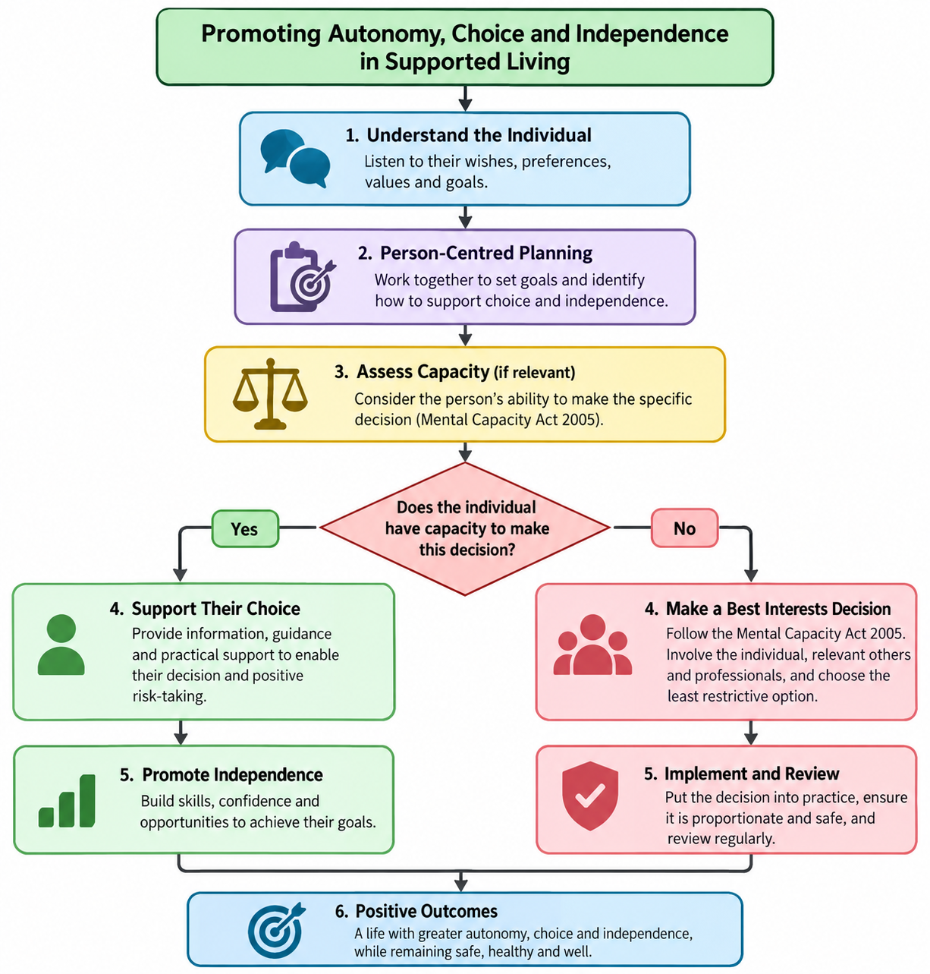

2- Autonomy, Choice and Independence in Supported Living Policy Easy Read

