

Complaints (Tell Us What You Think) Policy

1. Introduction
At Acorns Health Care, we believe that listening to the people we support, their families, representatives and professionals is fundamental to delivering safe, effective, compassionate and person-centred care. We are committed to creating an open, honest and inclusive culture where everyone feels confident to Tell Us What You Think, whether they wish to give a compliment, make a suggestion, raise a concern or make a complaint.
Our Tell Us What You Think approach encourages feedback, inclusive communication, and aims to use every piece of feedback we receive to make a positive difference to the care and support we deliver. We understand that what may seem like the smallest change can make a significant difference to the quality of people's care and support, their quality of life, and their overall experience.
We recognise that compliments allow us to celebrate excellent practice and acknowledge the dedication of our staff, while suggestions, concerns and complaints provide valuable opportunities to learn, improve and continuously strengthen the quality, safety and effectiveness of our services.
We believe that listening to people, acting on what they tell us, and sharing the improvements made as a result is central to delivering outstanding, person-centred care.
We want everyone to know that it is okay to complain if something has gone wrong. We encourage individuals to tell us when they are unhappy so that we can put things right as quickly as possible. Wherever possible, concerns will be resolved promptly through open discussion and early local resolution.
Where this is not possible, concerns will be investigated fairly, sensitively and transparently through our formal complaints procedure. If we are unable to resolve a complaint to the complainant's satisfaction, we will explain how they can request a review or escalate their concerns to senior management or external organisations.
Equally, we encourage people to tell us when we have done something well. Recognising good practice enables us to celebrate success, recognise the achievements of our staff and share examples of excellent care across the organisation. We also welcome suggestions that help us improve the way we deliver our services. This commitment is reflected in our Easy Read "Tell Us What You Think" document, which explains in an accessible format how individuals can make a complaint, give a compliment, seek support to complete forms and contact Head Office.
Acorns Healthcare has a dedicated feedback email addressfeedback@acornshealthcare.co.uk, where individuals receiving support, family members, professionals and members of the public are welcome to provide written feedback.
Professionals and family members can also share their feedback by scanning the QR code included in management email signatures and on the Acorns Health Care website. They are also encourages to share verbal feedback.
We encourage everyone to share their experiences, whether they are compliments, suggestions, concerns or complaints, as this helps us continually improve the quality of our care and support and ensure the voices of those we support remain at the heart of everything we do.
This policy sets out the values, principles and procedures that underpin how Acorns Health Care receives, manages and responds to compliments, suggestions, concerns and complaints. It complies with the Health and Social Care Act 2008 (Regulated Activities) Regulations 2014, specifically Regulation 16 – Receiving and Acting on Complaints, together with the Care Quality Commission Single Assessment Framework, ensuring individuals are encouraged and supported to express their views, are fully involved in decisions about their care and are informed of the outcomes of their feedback and any improvements made as a result.
Acorns Health Care is committed to ensuring that raising a concern or making a complaint is straightforward, accessible and free from barriers. Information is available in a range of accessible formats, including Easy Read, and individuals will be supported by staff, family members, advocates or representatives where required to express their views. Nobody will be treated unfairly, discriminated against or disadvantaged because they have raised a concern or made a complaint. People receiving support at Acorns Healthcare each have person centred care plan centred around how they can communicate their views.
We welcome all forms of feedback, including:
- Compliments – recognising when we have provided excellent care or support.
- Suggestions – ideas that could improve our services.
- Concerns – issues that can often be resolved quickly before becoming formal complaints.
- Complaints – telling us when expectations have not been met or when something has gone wrong.
Written complaints will normally be acknowledged within two working days, with investigations completed within 28 calendar days wherever possible. Where delays occur, complainants will be kept informed and provided with revised timescales. Complaints will be investigated fairly, impartially and transparently, with written outcomes explaining the findings, actions taken and the right to escalate the complaint where appropriate.
Where concerns involve abuse, neglect, criminal activity or serious risks to a person's health, safety or wellbeing, safeguarding procedures will take priority over the standard complaints process. Appropriate referrals will be made immediately to safeguarding authorities, commissioners and the Care Quality Commission where required.
Acorns Health Care works collaboratively with Local Authorities, commissioners, advocates and partner organisations to ensure concerns are managed effectively. Individuals who fund their own care will be informed of their right to refer unresolved complaints to the Local Government and Social Care Ombudsman. While the Care Quality Commission does not investigate individual complaints, it welcomes information about services and uses feedback to inform inspections and regulatory activity.
Above all, Acorns Health Care views every compliment, suggestion, concern and complaint as an opportunity to improve. Feedback forms an integral part of our governance, quality assurance and continuous improvement processes, helping us identify trends, improve policies and procedures, strengthen staff practice, recognise excellence and ensure the people we support continue to receive safe, effective, compassionate and high-quality care.

2. Purpose
The purpose of this policy is to provide a clear, fair, accessible and person-centred framework for receiving, managing and responding to compliments, suggestions, concerns and complaints across Acorns Health Care.
The policy supports our commitment to creating a culture of openness, transparency and continuous improvement, ensuring that every individual feels confident to Tell Us What You Think and knows that their feedback will be listened to, respected and acted upon.
This policy aims to:
- Encourage people to share compliments, suggestions, concerns and complaints.
- Ensure concerns are resolved quickly wherever possible.
- Provide a fair, consistent and transparent complaints process.
- Promote learning from feedback to improve service quality.
- Protect the rights of people using our services.
- Ensure compliance with all relevant legislation and regulatory requirements.
- Promote positive relationships built on openness, trust and respect.

3. Scope
This policy applies to every regulated service provided by Acorns Health Care.
It applies to:
- People who use Acorns Health Care services.
- Families and friends
- Appointees, deputies and advocates.
- Commissioners and Local Authorities.
- NHS organisations.
- Healthcare professionals.
- Contractors and partner agencies.
- Members of the public.
- All employees, agency staff, bank staff, volunteers, students and contractors working on behalf of Acorns Health Care.
This policy covers:
- Compliments.
- Suggestions.
- Informal concerns.
- Formal complaints.
- Verbal complaints.
- Written complaints.
- Electronic complaints.
- Complaints made through advocates or representatives.
Where concerns involve safeguarding, abuse, neglect, discrimination, criminal offences or professional misconduct, the appropriate safeguarding, disciplinary or statutory procedures will be followed alongside this policy.

4. Policy Statement
Acorns Health Care is committed to ensuring that every individual has the right to raise concerns, make complaints, offer suggestions and provide compliments without fear of discrimination, disadvantage or negative consequences.
We will ensure that:
- Every person is treated with dignity, respect and compassion.
- Feedback is welcomed and valued.
- Complaints are acknowledged promptly.
- Complaints are investigated fairly and impartially.
- Outcomes are explained clearly.
- Appropriate apologies are offered where required.
- Learning is identified and shared.
- Improvements are implemented and monitored.
- People are informed how to escalate complaints if they remain dissatisfied.
- Feedback is used to improve the quality and safety of our services.
This policy promotes learning rather than blame and supports an open, honest and transparent culture across Acorns Health Care.

5. Policy Review
This policy will be reviewed annually, or sooner where required, to ensure it remains compliant with current legislation, Care Quality Commission requirements, national guidance and recognised best practice.
The policy will also be reviewed following:
- Changes to legislation or regulations.
- Changes to CQC guidance.
- Learning from complaints or safeguarding investigations.
- Serious incidents.
- Internal or external audits.
- Inspection findings.
- Organisational changes.
- Significant service improvements or identified risks.

Responsibility for reviewing this policy rests with the Nominated Individual, Registered Managers and the senior leadership team.
Any amendments will be communicated to all staff, and updated versions of the policy will be made available throughout the organisation as part of Acorns Health Care's quality governance framework
Appendix 1; Complaints Flowchart
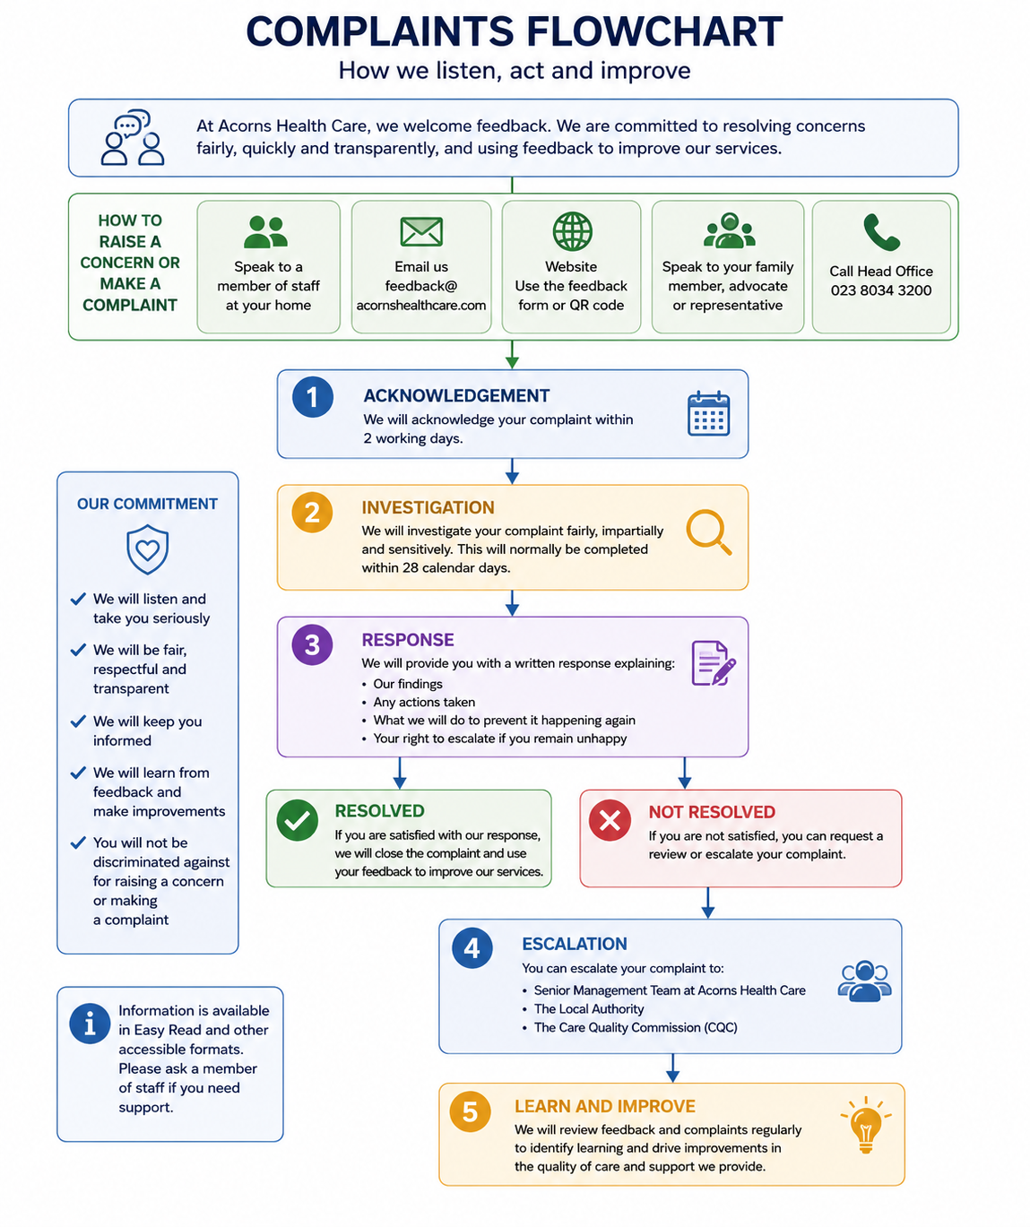

Appendix 2; Easy Read – Tell us what you think

This Easy Read tells you how to make a complaint or how to tell us when we did something well.
Telling us when we did something well is called a compliment.
Making a complaint





Making a complaint means telling us about something you do not like.
If something has gone wrong with your support from Acorns, we’d like you to tell us.
It is OK to complain.
It can be a good way to make things better.
When we know what is wrong, we can put it right.
If we don’t make things better the way you wanted us to, you can make an appeal.
An appeal means we will look at it again and see if we can do more to help you.

Sending us a compliment
When you think we’ve done something good, we’d love you to tell us. This is called a compliment. When you’re happy, we are happy too.
How to tell us what you think
You can fill out our Easy Read form to make a complaint or send us a compliment.




If you need any help with the form, ask someone you trust like a friend, a member of your family, or your support staff
You can also post a complaint or compliment to Acorns by emailing a copy of the form and sending it to us by letter or email or by calling Head Office

Address: The Barn, Calcot Mount Business Park, Calcot Ln, Curdridge, Southampton SO32 2BN

Phone: 01489 532099

Appendix 3; Complaints Form

Tell Us If You Are Worried or Unhappy
😊 We want to hear from you.
You can tell us if:
- ☐ You are unhappy.
- ☐ You are worried about something.
- ☐ You think something is unfair.
- ☐ You have a complaint.
- ☐ You want to tell us something else.

About You
Your name: ___________________________
Date: ________________________________
Would you like someone to help you complete this form?
☐ Yes
☐ No
If yes, who helped you?

What has happened?
Please tell us what happened.

How did it make you feel?
☐ Happy 😊
☐ Sad 😢
☐ Angry 😠
☐ Worried 😟
☐ Scared 😨
☐ Other: ______________________

What would you like us to do?
☐ Talk to me.
☐ Say sorry.
☐ Fix the problem.
☐ Explain what happened.
☐ Something else:

Who would you like to speak to?
☐ Staff Member
☐ Home Manager
☐ Regional Manager
☐ Family Member
☐ Advocate
☐ Someone else:

Is there anything else you want to tell us?

Thank You
Thank you for telling us.

❤️ We will:
- Listen to you.
- Take your concern seriously.
- Keep you updated.
- Try to put things right.
If you need help at any time, please ask a member of staff. We can also help you speak to an advocate if you would like independent support.
Version | 1
Date Reviewed | 21.07.2026
Policy Owner | Nominated Individual
Next Review Date | 20.07.2027
Review Frequency | Annually
Applies To | Individuals, Families and Professionals

